

**TRANSLATION FOR GUIDANCE**

**Conformity assessment of nuclear pressure equipment**

**GUIDE No. 8**

**Version revised on September 04, 2012**

**FRENCH NUCLEAR SAFETY AUTHORITY GUIDELINES**



















**Foreword**

*The ASN compendium of guidelines brings together documents for*

*professionals concerned by the nuclear safety and radiation protection regulations*

*(operators, users or transporters of ionising radiation sources, health professionals).*

*These guidelines may also be disseminated to various stakeholders,*

*such as the Local information commissions.*

*The aim of each guide, in the form of recommendations, is to:*

*- explain a regulation and the rights and obligations of the persons concerned by the regulation;*

*- explain the regulatory objectives and describe, as applicable, the practices that the French Nuclear Safety Authority deems satisfactory;*

*- provide practical elements and useful information on*

*nuclear safety and radiation protection.*



**Table of Contents**

1. **INTRODUCTION 6**

**1.1. CONTEXT AND REGULATORY REFERENCES 6**

**1.2. SCOPE 6**

**1.3. PURPOSE OF THESE GUIDELINES 7**

**1.4. STATUS OF THE DOCUMENT 7**

**1.5. STRUCTURE OF THE GUIDELINES 7**

**1.6. ABBREVIATIONS AND DEFINITIONS 8**

1.6.1 Abbreviations **8**

1.6.2 Physical persons and legal entities **9**

1.6.3 Technical definitions **9**

1. **GENERAL INTERVENTION PRINCIPLES OF NOTIFIED BODIES AND OPERATOR-SPECIFIC ORGANISATIONS 12**

**2.1. CLASSIFICATION OF NUCLEAR PRESSURE EQUIPMENT 12**

**2.2. CONFORMITY ASSESSMENT PROCEDURES FOR NUCLEAR PRESSURE EQUIPMENT 12**

**2.3. SELECTING THE NOTIFIED BODY OR OPERATOR-SPECIFIC ORGANISATION 14**

2.3.1 General rules 14

2.3.2 Rules of authorisation by ASN of the notified bodies for level N1 nuclear pressure

equipment 14

**2.4. CONFORMITY ASSESSMENT APPLICATION 14**

2.4.1 General description of the equipment, type or assembly 15

2.4.2 Technical documentation required to start, continue and complete the assessment of

the equipment, type or assembly 16

2.4.3 Documentation on the quality system implemented by the manufacturer 18

2.4.4 Information on the production schedule (except module H for level N1 equipment) 19

**2.5. SUBCONTRACTED OPERATIONS 19**

**2.6. DRAWING UP WORK REPORTS 19**

**2.7. DOCUMENTS ISSUED AT THE END OF THE CONFORMITY ASSESSMENT 19**

1. **ASSESSMENT WORK PERFORMED ACCORDING TO THE MODULES EXCLUDING**

**QUALITY ASSURANCE 20**

**3.1. ASSESSMENT OF THE MANUFACTURER’S RISK ANALYSIS 20**

**3.2. ASSESSMENT OF THE EQUIPMENT DESIGN 22**

3.2.1 Full use of a harmonised standard 22

3.2.2 Use of a reference system 22

3.2.3 Examination of the documentation 23

3.2.4 Experimental method 23

3.2.5 Prerequisites to the manufacturing operations 23

**3.3. ASSESSMENT OF BASIC AND FILLER MATERIALS 24**

* + 1. Assessment of the capacity of the material supplier’s inspection document to prove compliance with the essential requirements specified by the equipment manufacturer 25

3.3.2 Assessment of the EPMN 25

3.3.3 Manufacturing operations within the context of material development 26

**3.4. EXAMINATION OF THE OPERATING PROCEDURES FOR PERMANENT ASSEMBLIES 27**

**3.5. EXAMINATION OF THE QUALIFICATION FOR PERSONNEL BUILDING PERMANENT ASSEMBLIES 27**

**3.6. EXAMINATION OF THE QUALIFICATION FOR PERSONNEL PERFORMING NON-DESTRUCTIVE TESTS 28**

**3.7. INSPECTIONS DURING MANUFACTURE (MODULES B, F AND G) 28**

3.7.1 Information required for drawing up inspection plans 28

3.7.2 Minimum inspection frequency (excluding final verification) 29

3.7.3 Basic materials 30

3.7.4 Filler materials 30

3.7.5 Permanent assemblies and welded linings for N1 nuclear pressure equipment 31

3.7.6 Shaping 31

3.7.7 Test samples 31

3.7.8 Heat treatments 31

3.7.9 Non-destructive tests 32

3.7.10 Other manufacturing processes 32

3.7.11 Measuring instruments 32

3.7.12 Checking parts that will no longer be accessible during the final check 32

3.7.13 Rules related to component reassignment 32

3.7.14 Rules related to “supernumerary” productions 33

**3.8. ASSESSMENT OF INSTRUCTION MANUALS 33**

**3.9. FINAL CHECK (MODULES F AND G) 34**

3.9.1 Prerequisites to the final check 34

3.9.2 Documentation review 35

3.9.3 Visual examination 37

3.9.4 Pressure resistance test 40

3.9.5 Marking 40

**3.10. MONITORING OF THE FINAL CHECK (MODULES A1, C1) 41**

3.10.1 Changes to the types of equipment produced 41

3.10.2 Management of deviations detected by the notified body or the operator-specific

organisation 41

**3.11. TYPE EXAMINATION (MODULE B) 42**

**3.12. TYPE-EXAMINATION CERTIFICATE OR DESIGN-EXAMINATION CERTIFICATE**

**(MODULE B, B1) 42**

3.12.1 Issuing of the certificate 42

3.12.2 Refusal to issue the certificate 42

3.12.3 Supplement to a type-examination certificate or design-examination certificate 42

3.12.4 Renewal of a type-examination certificate 43

**3.13. IDENTIFICATION OF THE NOTIFIED BODY OR THE OPERATOR-SPECIFIC ORGANISATION 43**

1. **WORK TO BE PERFORMED AS PART OF THE CONFORMITY ASSESSMENT**

**OF ASSEMBLIES 43**

**4.1. DATA PROVIDED BY THE ASSEMBLY MANUFACTURER OR THE OPERATOR 43**

**4.2. RISK ANALYSIS 43**

**4.3. DESIGN ASSESSMENT 43**

**4.4. CONFORMITY ASSESSMENT OF EACH ITEM OF EQUIPMENT OR INTERMEDIATE ASSEMBLY 44**

**4.5. CHANGES TO EQUIPMENT OR INTERMEDIATE ASSEMBLIES 45**

**4.6. ACTIONS DURING INSTALLATION ACTIVITIES 45**

4.6.1 Actions during building of assemblies 45

4.6.2 Actions during other installation operations 46

4.6.3 Data required for drawing up the inspection plans 46

**4.7. ASSESSMENT OF THE PROTECTION AGAINST EXCEEDING THE ALLOWABLE**

**SERVICE LIMITS 46**

**4.8. FINAL CHECK 46**

**4.9. MARKING 47**

1. **ASSESSMENT WORK PERFORMED ACCORDING TO THE MODULES WITH QUALITY ASSURANCE (D, D1, E, E1, H, H1) 48**

**5.1. INITIAL ASSESSMENT OF A QUALITY SYSTEM (MODULES D AND D1) 48**

**5.2. INITIAL ASSESSMENT OF A QUALITY SYSTEM (MODULES E AND E1) 49**

**5.3. INITIAL ASSESSMENT OF A QUALITY SYSTEM (MODULES H AND H1) 49**

**5.4. MONITORING THE QUALITY SYSTEM (MODULES D, D1, E, E1, H, H1) 49**

5.4.1 Periodic audits 50

5.4.2 Unannounced inspections 50

5.4.3 Management of deviations detected by the notified body 50

**5.5. SPECIFIC ASSESSMENT OF THE QUALITY SYSTEM (MODULES D, D1, E, E1, H, H1) 51**

5.5.1 Modification of the quality system or the production facilities 51

5.5.2 Change in the scope of the assessment application 51

**5.6. NOTIFICATION OF DECISIONS FOLLOWING QUALITY SYSTEM ASSESSMENT**

**(MODULES D, D1, E, E1, H, H1) 51**

5.6.1 Initial audit 51

5.6.2 Monitoring 52

5.6.3 Information 52

**5.7. DESIGN EXAMINATION CERTIFICATE AND SPECIAL MONITORING OF THE FINAL CHECK (MODULE H1) 52**

**APPENDIX 1: Rules for classifying nuclear pressure equipment 53**

**APPENDIX 2: Summary of actions performed by the notified bodies or operator-specific organisations 62**

**APPENDIX 3: Standard content of an instruction manual 65**

# 1. Introduction

## **1.1. Context and regulatory references.**

The list of the main legal provisions and texts to which the guidelines refer is as follows:

[1] Article L592-21 of the French environment code.

[2] French Decree No. 99-1046 dated 13 December 1999 on pressure equipment (amended by French Decree 2007-1557 dated 2 November 2007) transposing the directive 97/23/EC dated 29 May 1997.

[3] French Decree 2007-1557 dated 2 November 2007 on licensed nuclear facilities and monitoring the transportation of radioactive substances with regard to nuclear safety.

[4] French Order dated 21 December 1999 on the classification and conformity assessment of pressure equipment.

[5] French Order dated 12 December 2005 on nuclear pressure equipment.

[6] European pressure equipment directive 97/23/EC adopted by the European Parliament and the European Council on 29 May 1997 on the harmonising of legislation on pressure equipment between member States.

[7] French Order dated 10 November 1999 on monitoring the operation of the main primary system and the main secondary systems of pressurised water reactors.

The French Nuclear Safety Authority (ASN) used the following supports to draw up this guide:

* The guide sheets related to application of the directive [6] and the transposing decree [2] except when the provisions of the order[5] supplementing or clarifying these texts prevail;
* Harmonised European standards;
* The sheets drawn up by the pressure equipment liaison committee (CLAP) which, unless otherwise stated by ASN, apply to nuclear pressure equipment;
* The sheets from the nuclear pressure equipment liaison committee (COLEN) validated by ASN and related to new nuclear pressure equipment.

## **1.2. Scope**

Article 11 of the Order [5] stipulates that the category I to IV and levels N1, N2 or N3 nuclear pressure equipment undergo conformity assessment carried out by a notified body or an operator-specific organisation according to one of the assessment modules described in Appendix 2 of the decree [2]. The conformity assessment procedure for assemblies composing at least one of these nuclear pressure equipment items is described in Article 12 of the order [5].

These guidelines apply to all notified bodies and operator-specific inspection organisations affected by implementation of these conformity assessment procedures which have been accredited by ASN according to the conditions of the ASN/GUIDE/5/1 guidelines, i.e.:

* The approved organisations mandated by ASN for the performance of all or part of the conformity assessment procedure of N1 nuclear pressure equipment or assemblies containing at least one of these equipment items;
* The organisations approved for conformity assessment within the conditions of module H for N1 nuclear pressure equipment;
* Notified bodies and operator-specific inspection organisations approved for the conformity assessment of N2 and N3 nuclear pressure equipment or assemblies containing at least one of these equipment items.

## **1.3. Purpose of these guidelines**

The purpose of the ASN guidelines No.8 is to explain the principles and conditions under which the notified bodies and operator-specific inspection organisations approved by ASN for the conformity assessment of nuclear pressure equipment and assemblies containing such equipment perform their work according to the provisions stipulated in Articles 11 and 12 of the order [5] and the assessment procedures described in the decree [2] referred to by said order.

It falls within the scope of ASN’s responsibilities with regard to monitoring the design and manufacturing of pressure equipment specially designed for nuclear application provided for in Article [1] of the French environment code.

ASN also uses these guidelines to mention the actions incumbent upon the manufacturers and operators of the nuclear pressure equipment required for application of the provisions regarding notified bodies and operator-specific inspection organisations.

Other conditions and practices may be substituted for those recommended herein after approval by ASN, if they meet the corresponding regulatory objectives.

## **1.4. Status of the document**

Further to publication of the order [5], a working group from the Central Committee for Pressure Vessels (CCAP) was created, during the meeting of 26 September 2006 of the standing nuclear section (SPN), in order to draw up guidelines on the conformity assessment of nuclear pressure equipment. SPN proposed to adopt the draft guidelines that the working group presented during the meeting dated 4 December 2008 and considered that they could be revised after a period of application. These draft guidelines became the ASN guidelines No.8 published in its version dated 31 March 2009.

Late 2010, at the request of the conformity assessment stakeholders, ASN implemented an approach with the aim of revising guidelines No.8 dated 31 March 2009 in order to take into account feedback from its application, all the discussions and observations regarding conformity assessment made since publication of the order [5] as well as the technical positions expressed by the COLEN[1] on new nuclear pressure equipment.

Accordingly, on 29 December 2010 ASN created a working group bringing together representatives from the industry involved in the conformity assessment of nuclear pressure equipment in particular manufacturers and organisations. This working group met 14 times between 19 January 2011 and 6 June 2012 and proposed draft modifications of the ASN guidelines No.8 which were presented to the advisory committee for nuclear pressure equipment (GP ESPN) during its meeting dated 5 July 2012.

These guidelines abrogate the previous version of the guidelines No.8 dated 31 March 2009 and include the recommendations made by the GP ESPN.

**1.5. Structure of the guidelines**

The ASN guidelines No.8 successively explain:

* The general intervention principles of the notified bodies and operator-specific inspection organisations;
* The assessment work to be carried out according to the modules except for quality assurance;
* The assessment work to be carried out according to the modules in addition to quality assurance;
* The work to be carried out for conformity assessment of the assemblies.

The appendix includes the following:

* A table outlining the classification of nuclear pressure equipment (appendix 1);
* A table summarising the actions taken by the notified bodies or operator-specific inspection organisations for each conformity assessment module (appendix 2). It refers to the detailed description of work to be performed which is explained in the body of the guidelines;
* A model instruction manual (appendix 3).

**1.6. Abbreviations and definitions**

1.6.1 Abbreviations

**APCRP** *Autre partie contribuant à la résistance à la pression* – Other part contributing to pressure resistance

**AP** *Autre partie* – Other part

**APP** *Autre partie sous pression* – Other pressure part

**APSRP** *Autre partie susceptible d’engendrer un risque vis-à-vis de la résistance à la pression* – Other part likely to create a risk with respect to pressure resistance

**ASN** *Autorité de sûreté nucléaire* – French nuclear safety authority

**CLAP** *Comité de liaison des appareils à pression* – Pressure equipment liaison committee

**COLEN** *Comité de liaison des équipements sous pression nucléaires* – Nuclear pressure equipment liaison committee

**CPP** *Circuit primaire principal* – Main primary system

**DESP** *Directive équipements sous pression* – Pressure equipment directive (PED) 97/23/EC dated 29 May 1997

**EIE** *Partie essentielle pour l’intégrité de l’équipement* – Essential part for equipment integrity

**EES** *Exigence essentielle de sécurité* – Essential safety requirement

**EPMN** *Evaluation particulière de matériau propre au domaine nucléaire* – Specific assessment of nuclear material

**END** *Essais non destructifs* – Non-destructive testing (NDT)

**ERP** *Exigence essentielle de radiation protection* – Essential radiation protection requirement

**ETPR** *Entité tierce partie reconnue* – Recognised third party organisation (RTPO)

**ESPN** *Equipement sous pression nucléaire* – Nuclear pressure equipment

**PP** *Partie sous pression* – Pressure part

**PPP** *Partie principale sous pression* – Main pressure part

**PS** *Pression maximale admissible définie au point h) de l’article 1 du décret* [*2*] – Maximum allowable pressure defined in point h) of Article 1 of the Decree [2]

**QMOAP** *Qualification de mode opératoire d’assemblage permanent* – Permanent assembly operating procedure qualification

**QMOS** *Qualification de mode opératoire de soudage* – Welding operating procedure qualification

**QPAP** *Qualification du personnel en charge des assemblages permanents* – Qualification of personnel responsible for permanent assemblies

**QT** *Qualification technique* – Technical qualification

**TS** *Température minimale/maximale admissible telle que définie au point i) de l’article 1 du décret [2]* – Minimum/maximum allowable temperature as defined in point i) of Article 1 of the decree [2]

1.6.2 Physical persons and legal entities

**National regulatory authority for ESPNs:**

French nuclear safety authority (ASN)

**Notified and approved body[2]:**

A notified body is an organisation that has been approved according to Article 9 of the decree [2], notified to the European Commission under the terms of the PED (Art. 12) and approved by ASN for conformity assessment of nuclear pressure equipment pursuant to the order [5]. Notified and approved bodies are referred to as notified bodies throughout the rest of the document.

**Operator-specific inspection organisation:**

An inspection organisation inherent to an industrial group approved according to Article 14 of the decree [2], notified to the European Commission under the terms of PED (Art. 14) and approved for the conformity assessment of nuclear pressure equipment by ASN according to modules A1, C1, F and G (excluding level N1) pursuant to the order [5]. The operator-specific inspection organisations are referred to as operator-specific organisations throughout the rest of the document.

**Recognised third party organisation (RTPO):**

Organisation recognised by a member State under the terms of the Pressure Equipment Directive (Art. 13) to carry out QMOAP and QPAP approvals or to approve personnel responsible for non-destructive testing (NDT).

**Manufacturer:**

Physical person or legal entity which assumes the responsibility for the design, manufacture and inspection of a product to be marketed under his/her/its name as an item of nuclear pressure equipment or an assembly containing at least one item of nuclear pressure equipment. The manufacturer can be responsible for the design, manufacture and inspection on its own or he/she/it can subcontract all or part of the design, manufacture and inspection process. In this case, the manufacturer retains liability as the manufacturer.

**Subcontractor:**

Physical person or legal entity that carries out a design, manufacturing or inspection operation on behalf of and under the responsibility of a manufacturer in accordance with the requirements defined and set by the manufacturer.

1.6.3 Technical definitions

**Nuclear pressure equipment (ESPN):**

Equipment that meets the following conditions is considered to be nuclear pressure equipment:

* Defined by I of Article 2 of the decree [2], except for equipment which is mentioned in points “a” to “r” of II of Article 2;
* Used or intended for use in a licensed nuclear facility as defined in 2° of Article 4 of French Act dated 13 June 2006;
* Directly used to confine radioactive substances under the conditions defined for their operation;
* Resulting in radioactive releases over 370 MBq in the event of a failure, assessed in compliance with II of Article 2 of the order [5].

An item of nuclear pressure equipment is composed of various parts. The permanent assemblies attached to pressure parts of nuclear pressure equipment and built under the manufacturer’s liability are considered to be an integral part of this equipment.

**Pressure part (PP):**

Part used to pick up the loads due to pressure. These parts can possibly be broken down into main pressure parts (PPP) and the other pressure parts (APP).

The main pressure parts are composed of the following parts:

* The parts making up the equipment casing. In the case of a vessel, it is designed and built to contain pressurised fluids. These parts are necessarily in contact with pressurised fluids;
* The parts which are essential for equipment integrity (EIE). According to the guide sheets in particular 7/6 and 7/8, these parts can be defined as parts whose failure may cause sudden discharge of the energy contained.

The other pressure parts are used to pick up the loads due to pressure. They may include for example the nuts and bolts whose failure may lead to a sudden discharge of the energy contained.

**Other part contributing to pressure resistance (APCRP):**

This part is a component of an item of nuclear pressure equipment designed to contribute to pressure resistance which, if it experiences function loss, may in the medium to long term result in a loss of the equipment item integrity or of one of its parts through any failure mode. This may involve for example components whose function is to support and not strengthen the equipment casing, an anticorrosion lining or even for a steam generator, antivibration bars of the tube bundle or the tube support plates.

**Other part likely to create a risk with regards to pressure resistance (APSRP):**

Part of a nuclear pressure equipment item which may directly or indirectly play a role in aggressing the parts contributing to pressure resistance. It may involve for example a part of an equipment item which can be detached and needing requirements to ensure its attachment and security (for example bolt from the reactor coolant motor pump or the internal part of a steam generator).

**Assembly:**

An assembly is composed of several pressure equipment items with at least one nuclear pressure equipment item, assembled by a single manufacturer to form an integrated and functional unit. An assembly may contain intermediate assemblies. An assembly cannot contain a portion of an equipment item and must necessarily stop at the end of an equipment item. For example, the main primary system (CPP) of a pressurised water reactor cannot be considered an assembly. The assembly can be completed by the manufacturer on site or in its workshops.

**Intermediate assembly:**

Assembly included in a larger assembly referred to as a final assembly. The manufacturer of an intermediate assembly may differ from the manufacturer of the assembly in which it will be integrated.

**Integration:**

All the design and manufacturing actions performed under the assembly manufacturer’s responsibility and with the aim of ensuring appropriate resistance of the assembly.

**Assembling:**

The manufacturing actions performed under the assembly manufacturer’s responsibility except for manufacture of intermediate assemblies or equipment assessed within the framework of the assembly. Assembling may include operations such as handling, attachment of equipment or intermediate assemblies on the supports, performance of assembling between the intermediate assemblies or equipment, installation of heat insulators, performance of inspections and tests.

**Installation (Actions):**

Actions performed on the pressure equipment or assemblies after they are marketed under the responsibility of the operator in compliance with the requirements stipulated by Article 13 of the order [5]. If an item of equipment assembled together which does not comply with the definition of “integrated and functional unit” is supplied to the operator, the operator shall be responsible for assembling said equipment under installation even if said assembling is not carried out on site.

**Specific assessment of nuclear material (EPMN):**

Demonstration given by the manufacturer of a nuclear pressure equipment item for each basic or filler material making up a nuclear pressure equipment item that complies with the requirements identified in the risk analysis related thereto. This may involve the requirements of the order [5] and those to which it refers, requirements related to highly improbable situations or additional requirements as defined in paragraph 3.1.

**Type (see CLAP sheet 149):**

Sample that is characteristic of a family that undergoes type examination or design examination.

Note: Regulations also use the word “type” to distinguish vessels, piping, pressure fittings and safety accessories. This very general acceptance of the word “type” is different from the meaning that is defined in these guidelines.

**Family (see CLAP sheet 149):**

A group or version of pressure equipment which is covered by the type examination or design examination certificate.

**Approval of a quality system:**

For the quality system, the term “approval” will be used to mean:

* Approval as defined in appendix 2 of the decree [2] in point 6 of modules D and E and point 7 of modules D1 and E1,
* Approval as defined in appendix 2 of the decree [2] in point 6 of module H.

# 2. GENERAL INTERVENTION PRINCIPLES OF NOTIFIED BODIES AND OPERATOR-SPECIFIC ORGANISATIONS

# 2.1. Classification of nuclear pressure equipment

Nuclear pressure equipment is classified into 3 levels based on the amount of radioactivity that could be released in the event of equipment failure (from N1 to N3 by decreasing order of release) and into 5 categories (0, I, II, III and IV) based on the pressure-related risk.

Figures 1 to 8 and table 6.1 in appendix 1 help to determine the risk category of the various types of nuclear pressure equipment (safety accessories, vessels, pressure fittings, piping) based on their level and the nature of the fluid contained therein.

**2.2. Conformity assessment procedures for nuclear pressure equipment**

# The procedure governing conformity assessment of nuclear pressure equipment is determined by the equipment manufacturer based on its level, risk category and nature. It results from application of the modules mentioned in appendix 2 of the decree [2], or the combination of these modules. The possible choices are presented in tables 2.2 a) and 2.2 b) below:

|  |  |  |  |
| --- | --- | --- | --- |
| Table 2.2 a) | N1 | N2 | N3 |
| Pressure or safety containers or accessories  Category I or II | G+H | G; B+F; B+C1; B1+F; B+D; B1+D; B+E; H; H1 | The applicable conformity assessment procedures are those provided by the order [4]  Refer to table 2.2 b) |
| Pressure or safety containers or accessories  Category III or IV | G+H | G; B+F; B+D; H1 |
| Piping  (except small diameter piping specified below) | G+H | G; B+F; B1+F; B+C1; B+D; B+E; B1+D; H; H1 |
| CPP nominal diameter piping (DN) ≤ 50 + piping of the other systems of category  I or II and of DN ≤  100 as well[3] as the pressure accessories of the same nominal diameter that are connected to them | B+F; B+D; G; H1 | Does not exist | Does not exist |

|  |  |  |  |
| --- | --- | --- | --- |
| Table 2.2 a) | N1 | N2 | N3 |
| Pressure accessories marked CE | Not usable | Not usable if the conformity assessment was based on module A.  In the other cases, an additional assessment must be performed by the notified bodies or operator-specific organisations. | |
| Assemblies containing at least one category I to IV item of nuclear pressure equipment | Conformity assessment of each nuclear pressure equipment of category I to IV comprising the assembly when said equipment has not undergone a previous assessment.  Assessment of the integration of the final assembly:  - assessment of the design, which includes among others the assessment of the protection against exceeding the permissible service limits according to the conformity assessment procedure determined by the highest level and category for the equipment to be protected;  - assessment of the assembling of nuclear pressure equipment or intermediate assemblies making up the final assembly in particular conformity assessment of the assembling of equipment or intermediate assemblies together in accordance with the requirements and the conformity assessment procedure determined by the highest level and category for the equipment in question.  Performance of a final check comprising the operations provided for in 3.2.1 and 3.2.2 of appendix 1 of the decree [2].  The manufacturer of an assembly comprising at least one N1 item of nuclear pressure equipment subject to the requirements of appendix 1 of the order [5] must have received an approval of its quality system according to module H appropriately covering manufacture of the assemblies. | | |

Table 2.2 b) below specifies the possible conformity assessment procedures for level N3 nuclear pressure equipment based on their risk category:

|  |  |  |  |  |
| --- | --- | --- | --- | --- |
| Table 2.2 b) | Without Quality Assurance | | With Quality Assurance | |
| Series | Unit | Series | Unit |
| Cat. I | A | | A | |
| Cat. II | A1 | | D1 (Production) or E1 (Product) | |
| Cat. III | B+C1 | B1+F | B+E or B1+D or H | H or B1+D |
| Cat. IV | B+F | G | B+D or H1 | H1 |

The conformity assessment according to module A is solely incumbent upon the manufacturer and does not require the involvement of a notified body. The manufacturer can decide to apply a conformity assessment procedure corresponding to an assessment module stipulated for the risks category of its equipment item or for a higher category.

There are no conformity assessment procedures for category 0 nuclear pressure equipment. With regard to their design and manufacture, they must comply with best practices and with the radiation protection requirements of the order [5]. An assembly made up only of category 0 equipment does not need to undergo a conformity assessment procedure. Whenever such an assembly is integrated in assembly subject to conformity assessment, the notified body or inspection organisation must ensure that it corresponds to the definition of an integrated and functional unit.

**2.3. Selecting the notified body or operator-specific organisation**

2.3.1 General rules

The conformity assessment of N1 nuclear pressure equipment subject to the requirements of appendix 1 of the order [5], as well as that of the assemblies containing at least one of these equipment items is performed by the French nuclear safety authority which can commission another body for all or part of the required operations.

The conformity assessment of level N2 and N3 nuclear pressure equipment as well as those of assemblies containing this type of nuclear pressure equipment may be performed by a notified body or an operator-specific organisation. The latter is only involved in the scope of conformity assessment procedures corresponding to modules A1, C1, F and G of appendix 2 of the decree [2].

A notified body performs the conformity assessment of level N1 nuclear pressure equipment exclusively[4] subject to the requirements of Appendix 2 of the order [5], as well as that of the assemblies composing N1 level equipment exclusively of this type.

The notified bodies and operator-specific organisations perform their conformity assessment tasks in accordance with internal procedures based on these guidelines.

2.3.2 Rules of authorisation by ASN of the notified bodies for level N1 nuclear pressure equipment

ASN selects the notified body that it mandates based on a proposal made by the manufacturer. Once the mandate is issued, the notified body cannot be changed save in exceptional circumstances.

Different notified bodies cannot be mandated to assess the design, monitor the manufacturing phases and perform final check of a nuclear pressure equipment item.

If a different notified body is selected to monitor manufacturing of equipment of the same design, the technical documents required by the regulations must be transmitted for each equipment item and the design assessed by each notified body.

ASN will examine on a case by case basis the proposals for mandating a different notified body to monitor the procurement phase of components subject to technical qualification and manufacture of the equipment to which they are intended. This last configuration must be exceptional.

**2.4. Conformity assessment application**

The manufacturer must apply for assessment either to the French nuclear safety authority, the notified body or the operator-specific organisation, as per the provisions stipulated in paragraph 2.3 within the timeframe required for a notified body or operator-specific organisation to schedule and perform the first step in the conformity assessment in compliance with the chosen module. The notified body or operator-specific organisation will determine whether it has sufficient elements to start the conformity assessment.

The assessment application must include the items listed in Table 2.4 below depending on the relevant module(s).

|  |  |  |  |  |  |  |  |  |  |  |  |  |  |
| --- | --- | --- | --- | --- | --- | --- | --- | --- | --- | --- | --- | --- | --- |
| Table 2.4 | | A1 | B | B1 | C1 | D | D1 | E | E1 | F | G | H | H1 |
| Written statement specifying that this request has not been made to another body or organisation. |  |  | X | X |  |  |  |  |  |  | X |  |  |
| Agreement by the manufacturer to provide free access to its facilities and to those of its subcontractors as applicable |  | X | X | X | X | X | X | X | X | X | X | X | X |
| General description of the equipment, the type or the assembly | See  § 2.4.1 | X | X | X |  |  | X |  | X |  | X |  |  |
| Technical documentation for assessment | See  § 2.4.2 |  | X | X |  |  |  | X  (1) | X  (1) |  | X |  | X |
| Documentation on the quality system. | See  § 2.4.3 |  |  |  |  | X | X | X | X |  |  | X | X |
| Information on the equipment production schedule. | See  § 2.4.4 | X |  |  | X | X | X | X | X |  |  | X | X |
| Agreement to provide a characteristic copy of the type. |  |  | X |  |  |  |  |  |  |  |  |  |  |
| Type examination or design examination certificate and technical documentation for the approved type. |  |  |  |  | X | X |  | X |  | X |  |  |  |

*Note (1): the technical documents are made available to the notified body by the manufacturer within the context of the inspection visits of the inspection, test and storage locations to check correct implementation of the obligations resulting from the quality system.*

With regard to assemblies, the assessment application will moreover include the list of equipment items composing the assembly with a list of their classification and level and will state whether the equipment has been subject to conformity assessment or is assessed within the framework of the assembly.

2.4.1 General description of the equipment, type or assembly

The general description must include the following information:

* Manufacturer’s name and address.
* List of any subcontractors.
* Identification or description of the equipment, type or assembly.
* General documentation describing the equipment, type or assembly.
* Installation conditions.
* Definition of the physical limits of the equipment or assembly.
* For each item of equipment and possibly each compartment:

- Fluid contained, state and group;

- Maximum allowable pressure PS;

- Minimum and maximum design pressures (vacuum),

- Minimum and maximum temperature TS;

- Minimum and maximum design temperatures;

- N1, N2 or N3 level;

- Risk category.

* For the assemblies, their function.

2.4.2 Technical documentation required to start, continue and complete the assessment of the equipment, type or assembly

Table 2.4.2 below states the type of technical documentation that the manufacturer must transmit or hold at the disposal of the notified body or operator-specific organisation. This list must be adapted depending on the relevant conformity assessment modules and must be broken down for each subcontractor as applicable.

|  |  |  |  |
| --- | --- | --- | --- |
| Table 2.4.2 | Prior to assessment | During assessment  (2) | Before the end of assessment  (1) |
| **Data supplied by the operator or the manufacturer of the assembly consistent with the safety report (3):** |  |  |  |
| - Sets of situations in which the equipment or assembly can be found | X |  |  |
| - Description of the situations and sets of loads to be taken into account | X |  |  |
| - Data on the radioactive nature of the fluid | X |  |  |
| - Requirements for highly improbable situations | X |  |  |
| - Requirements on in-service inspections | X |  |  |
| - Specific requirements on materials in relation with the intended application | X |  |  |
| - Other additional requirements | X |  |  |
| **Data supplied by the manufacturer (3):** |  |  |  |
| - List of harmonised standards and solutions adopted to meet the requirements of the order [5] (codes, technical standards, etc.) | X |  |  |
| - Risk analysis taking into account all the operator – supplied data on pressure risk and radioactive nature of the fluid | X |  |  |
| - Description of the methods used for in-service inspections, bearing in mind the radioactivity | X |  |  |
| - Design drawings, production drawings, diagrams of components (to draw up the inspection plans as applicable), subassemblies or circuits, key to understanding the drawings and diagrams (if necessary) | X | X (manufacturing drawings if not already submitted) |  |
| - Solutions adopted for marking and labelling | X |  |  |
| - List of basic materials used and proof that the material is suitable for the given application including technical qualification files when required | X (4) |  |  |

*Note (1): if modules B1 and H1 are applied, the documentation must be supplied prior to the end of the design assessment. For all modules, priority should be given to early examination of the documentation.*

*Note (2): the documents must be submitted within a timeframe to allow their assessment before performance of the relevant operation. With regard to modules E and E1, the technical documentation is provided by the manufacturer to the notified body as part of the inspection visits of the inspection, test and storage locations to check proper implementation of the obligations resulting from the quality system.*

*Note (3): the manufacturer is responsible for filing the technical documentation. The notified body or operator-specific organisation keeps the data transmitted by the manufacturer or operator in accordance with its approval reference system.*

*Note (4): the relevant items concerning proof of the suitability of the material with the given application may appear in an initial version of the EPMN transmitted at the start of the assessment.*

|  |  |  |  |
| --- | --- | --- | --- |
| Tableau 2.4.2 | Prior to assessment | During assessment  (2) | Before the end of assessment  (1) |
| - EPMN for the basic materials and filler materials |  |  | X |
| - Specifications for the supply of the basic materials and filler materials |  | X |  |
| - Traceability procedures for the basic materials and filler materials | X |  |  |
| - Notes justifying the calculation thickness in the case of a design by calculation and any other predimensioning document for N1 | X |  |  |
| - Design notes justifying correct equipment behaviour for each possibility of damage from the different cases of load combinations |  |  | X |
| - Programme for design by experimental method or by calculation supported by tests | X |  |  |
| - Test reports for experimental method design or design by calculation supported by tests |  | X |  |
| - Procedures or methods used for shaping, assembling (welding data package) including welding coatings if N1 and repair, heat treatments and non-destructive testing |  | X |  |
| - Instruction manual |  |  | X |
| - Documents on the qualification and if required the approval of the operating procedures for permanent assemblies including for repair (and welded coatings if N1) |  | X |  |
| - Non-conformity reports likely to have an impact on the requirements identified by the risk analysis and the repair procedures as applicable |  | X(5) |  |
| - Pressure resistance test procedures as applicable | X(6) | X |  |
| - Any other document that can be used to show compliance with the requirements identified by risk analysis |  | X |  |
| **Data supplied by the manufacturer (7):** |  |  |  |
| - Reports of NDT scheduled by the risk analysis |  | X |  |
| - Data related to heat treatments |  | X |  |
| - Destructive test reports (test samples) |  | X |  |
| - Reports of dimensional inspections scheduled by the risk analysis |  | X |  |
| - Documents on the inspection of the basic materials and filler materials |  | X |  |
| - Documents on the qualification and if required the approval of personnel responsible for producing the permanent assemblies (and welded coatings if N1) and carrying out non-destructive testing |  | X |  |

*Note (5): the non-conformity report is to be supplied as soon as a deviation likely to jeopardise a requirement identified in the risk analysis is determined prior to implementation of the selected solution.*

*Note (6): the procedure must be approved at the design stage if the equipment in particular due to its size or production mode cannot be subject to the entire pressure resistance test.*

*Note (7): the data supplied by the manufacturer or the operator is not kept by the notified body.*

The technical documentation mentioned above is to be supplied for the equipment or intermediate assemblies comprising an assembly which will be assessed as part of the conformity assessment of the assembly.

With regard to assemblies, the technical documentation must be composed of:

* Relevant elements of the documentation specified in paragraph 2.4.2;
* The assembling list of the assembly (other than between category 0 equipment) specifying for each assembly, the level and category of each related item of equipment, the intended assembling mode, the selected assessment module(s);
* For intermediate equipment or assemblies already assessed, the statement and certificate of conformity and the instruction manual. They must be supplied at the latest before installation of the assembly equipment;
* The list of safety accessories as well as the level and category of the equipment to be protected.

The manufacturer of the final assembly must take all the necessary measures so that the notified body or the operator-specific organisation has all the information concerning the intermediate assemblies or equipment required for the conformity assessment of the final assembly. Accordingly, it shall ensure that the above documentation enables the notified body or operator-specific organisation to perform all the operations mentioned in paragraph 4 of these guidelines.

Where necessary, the notified body or operator-specific inspection organisation must have access to all or part of the technical documentation used for the conformity assessment of intermediate assemblies or equipment which have undergone prior individual conformity assessment.

Likewise, the manufacturer of the final assembly must be able to answer any questions posed by the notified body or the operator-specific inspection organisation regarding the integration of the intermediate assemblies or equipment exempt from the conformity assessment procedure.

2.4.3 Documentation on the quality system implemented by the manufacturer

In accordance with the provisions stipulated by the modules with quality assurance of appendix 2 of the decree [2], the notified body must have access to any documentation it deems fit to assess the manufacturer’s quality system. This documentation must at least include the following information:

* Family(ies) of pressure equipment covered by the quality system.
* Manufacturer’s agreement to meet the quality system obligations and to ensure it is appropriate and effective.
* Manufacturer’s agreement to inform the notified body of any plan to change a previously approved quality system.
* Copy of the document certifying the quality system, if it has been certified.
* Manuals or drawings defining the quality objectives, the organisation flow charts, management staff’s responsibilities and powers with regard to the quality of the pressure equipment.
* Agreement to provide documents on the following subjects during the conformity assessment of the quality system and the monitoring actions implemented:

- Monitoring of the quality system;

- Design verification;

- Monitoring of the design document modifications (drawings, calculations, specifications and instructions);

- Procurement of materials, products and components;

- Material and component traceability;

- Manufacture, inspection and tests;

- Programmes defining the inspections and tests to be performed before, during and after manufacture, with information on their scope and frequency (for example list of manufacturing and inspection operations, etc.);

- Qualification of the operating procedures for the permanent assembly;

- Qualification of the personnel responsible for building the permanent assemblies and carrying out non-destructive testing;

- Calibration and verification of the inspection, measurement and testing instruments and equipment;

- Subcontractor monitoring;

- Management of non-conformities identified during design, manufacture, inspection, testing and final verification;

- The records for previously manufactured equipment as provided for by the procedures and the procedure application documents.

2.4.4 Information on the production schedule (except module H for level N1 equipment)

Proper monitoring in the case of the quality modules requires the manufacturer to send the notified body its planned production schedule for the relevant module and a review every year of the equipment that has been made bearing the number of the notified body. In the case of modules A1 and C1, each final check period must also be the subject of such information.

**2.5. Subcontracted operations**

Whenever the manufacturer subcontracts operations, the notified body or operator-specific inspection organisation must have free access to the subcontractor’s premises in order to be able to perform any inspections there that it deems necessary to check compliance of the requirements stemming from the risk analysis or as applicable that the manufacturer properly meets the obligations of the approved quality system.

**2.6. Drawing up work reports**

Any work carried out by a notified body or an operator-specific organisation must give rise to the drafting of a report at least specifying:

* The detail of the service performed;
* The observations made;
* Any deviations identified as well as their management.

The notified body or the operator-specific organisation will decide at its discretion whether it is possible to transmit the work reports to the manufacturer and under what conditions. The observations stemming from the inspections must be promptly transmitted to the manufacturer so that it can take all the relevant corrective and preventive measures as soon as possible.

Work reports must be transmitted to third parties in compliance with the confidentiality requirements specified in the approval reference system of notified bodies and operator-specific organisations.

**2.7. Documents issued at the end of the conformity assessment**

Following a satisfactory assessment, the notified body or the operator-specific organisation issues the document required by the conformity assessment module applied in accordance with appendix 2 of the decree [2]. In case of N1 level equipment, the document required under module G is only issued by ASN after it has checked that the manufacturer is in possession of the valid document required under module H.

**3. ASSESSMENT WORK PERFORMED ACCORDING TO THE MODULES EXCLUDING QUALITY ASSURANCE**

**3.1. Assessment of the manufacturer’s risk analysis**

The notified body or operator-specific organisation will check at least that:

* The risk analysis is not restricted to pressure parts and that it also takes into account the assembly:
* Essentials safety requirements;
* Radiation protection requirements;
* Requirements relating to highly improbable situations (HIS);
* As required, additional requirements.
* The list of hazardous phenomena and the associated failure modes taken into account depending on:

- The exhaustiveness of the loads and situations transmitted by the operator,

- The design basis selected such as drawings, materials, etc.

- Feedback from the notified body.

* The appropriate nature of the measures taken by the manufacturer:

- For design and manufacturing conditions eliminating or reducing the hazardous phenomena;

- To protect against hazardous phenomena which cannot be eliminated;

- To inform the operator through instruction manuals of the residual risks or the incorrect conditions of use.

This verification is carried out for each situation in which the equipment can be found whether it is reasonably foreseeable or highly improbable. The requirements which apply to highly improbable situations are those supplied to the manufacturer by the operator in consistency with the safety report, in addition to those stemming from the manufacturer’s risk analysis for the situations.

Additional requirements related with the pressure risk may also be defined. They must stem from the manufacturer’s risk analysis or must be supplied to the manufacturer by the operator in line with the safety report.

The manufacturer performs a risk analysis which must cover all parts of the equipment and all its life phases until it is put out of service. The analysis also concerns all actions that the manufacturer performs under its responsibility before the end of the conformity assessment such as the transport operations, functional tests or storage conditions.

The risk analysis must also identify the essential safety and radiation protection requirements for which a visual inspection must be carried out to check compliance therewith and which will form the subject of the visual examination of the final verification according to the conditions mentioned in paragraph 3.9.3.

For level N1 nuclear pressure equipment, the manufacturer:

* Performs, during the risk analysis, a classification of the equipment parts depending on their role with regard to pressure resistance by making a distinction between:

- Pressure parts (PP),

- Other parts contributing to pressure resistance (APCRP),

- Other parts likely to create a risk with respect to pressure resistance (APSRP)

- Other parts (AP) not representing a risk with respect to pressure resistance.

* Describes the requirements which apply to each part.

The analysis of level N1 nuclear pressure equipment is based on a physical and functional description of the equipment and its parts including the assembling, identification of hazardous phenomena and the causes of functional losses which help to identify the applicable requirements.

Whenever necessary, the risk analysis must be reassessed or updated. The requirements which apply to the APSRP are considered additional requirements except for radiation protection requirements.

Flow chart 3.1 summarises the classification approach of level N1 nuclear pressure equipment parts:

Used to pick up loads due to the pressure

**Pressure part (PP)**

Sudden energy discharge

Contributing to pressure resistance

**Enveloppe sous pression**

**Enveloppe sous pression**

**APCRP**

Direct or indirect aggressive role

**AP**

**APSRP**

**Parts**

**PPP**

**APP**

**EIE**

**Pressure boundary**

**YES**

**YES**

**YES**

**YES**

**NO**

**NO**

**NO**

**NO**

Flow chart 3.1

**3.2. Assessment of the equipment design**

3.2.1 Full use of a harmonised standard

The notified body or the operator-specific organisation will check that the requirements stemming from the risk analysis have been taken into account. This check is carried out on the basis of:

* Appendix ZA of the standard;
* A document from the manufacturer clarifying the additional provisions adopted to meet the essential safety requirements and the radiation protection requirements which are not addressed by the standard.

A special analysis must be performed by the notified body or the operator-specific organisation to assess the validity of the additional provisions adopted including those for highly improbable situations.

The notified body or the operator-specific organisation will check that the provisions of the standard have been satisfied and that the manufacturer has applied them including the additional provisions.

3.2.2 Use of a reference system

The manufacturer may choose a technical reference system composed of a code, non-harmonised standards, or even technical specifications. The notified body or the operator-specific organisation will check in this case that the requirements stemming from the risk analysis have been taken into account. This check is carried out on the basis of:

* An integral part of the code clarifying the provisions set therein to meet the requirements stemming from the risk analysis and a document outlining the additional provisions adopted to meet the essential requirements which are not addressed by the code;

OR

* An analysis supplied by the manufacturer explaining how the provisions of the reference system meet the requirements stemming from the risk analysis.

In all cases, a special analysis must be performed by the notified body or the operator-specific organisation to assess the validity of all the provisions adopted. The notified body or the operator-specific organisation will check that all stages of the reference system have been satisfied and that the manufacturer has applied them including the provisions for highly improbable situations and the additional requirements stemming from the risk analysis.

Except in the case of an analysis provided by the manufacturer explaining how the provisions of the reference system meet the requirements stemming from the risk analysis, the rule in the case where a code is used is to use a single code for an item of equipment in a given version identified in the technical documentation. Subsequent modifications of the given version of the code may be chosen by the notified body subject to the following conditions:

• They can be explicitly declared as being compatible with the given version by the publisher of the code;

• The manufacturer justifies that the modifications maintain the consistency of the chosen provisions and therefore compliance with the applicable requirements;

• The agreement of the notified body or operator-specific organisation is explicitly given;

• The manufacturer takes account of any conditions associated with their application.

In general, the manufacturer must provide proof that the modifications of the reference system used allow the requirements stemming from the risk analysis to be met.

3.2.3 Examination of the documentation

This examination concerns the technical documentation defined in paragraph 2.4.2, in particular the appended drawings and documents (e.g. equipment specifications, etc.). In general, the check concerns the following:

* Overall examination of the equipment dimensions and geometry (body, blend radii, supports, fastenings, nozzles, etc.);
* The conformity of the types of assembly with the chosen technical reference system;
* Due consideration of the applicable requirements (identification of the areas subject to fatigue, equipment selected for in-service inspection by taking into account radioactivity, marking, draining and ventilation methods, radiation protection requirements, etc.);
* Consistency of the data within the drawings and documents and with the risk analysis status,

The examination of the notified body or the operator-specific organisation concerns the following in the case of a design by calculation:

* Conformity of the input data to the situations and loads supplied by the operator;
* The geometric data taken into account;
* Conformity of the material characteristics included with the characteristics guaranteed by the harmonised standard or the material assessment (refer to paragraph 3.3);
* Checking that the method:

- complies with the applicable technical reference system;

- can deal with all applicable requirements taking into account the chosen failure mode;

- is used within its area of validity;

- is implemented with appropriate technical resources;

* Consistency of the output data (a check calculation may be carried out).

3.2.4 Experimental method

The experimental design method is not accepted for modules B1 and H1. For the other modules, it is only implemented if necessary in addition to a design method or alone for the non-N1 level equipment whose PSxV product is less than 6000 bar.L or PSxDN product is less than 3000 bar. The conditions for implementing the experimental design method are specified in point 2.2.4 of appendix 1 of the decree [2].

3.2.5 Prerequisites to the manufacturing operations

An examination concerning all the irreversible design choices in particular with regard to dimensioning and the choice of materials must be carried out prior to manufacturing equipment in the scope of the conformity assessment.

It will include an examination of documentation which will cover examination of the following:

* Justification of the design or the dimensioning thickness,
* Justification of suitability of the material specifications and the equipment selected to enable in-service inspection,
* Identification of the areas subject to fatigue and the measures taken to prevent this risk as required,
* Description of the equipment considered for in-service inspections, taking into account radioactivity.

A good practice is for the notified body or operator-specific inspection organisation to put its conclusion into writing.

The examination of the design note justifying the correct behaviour of the as built equipment for each case of damage, resulting from the different load combinations is not a prerequisite to the manufacturing operations and must be carried out before the end of the final verification.

**3.3. Assessment of basic and filler materials**

The equipment manufacturer must prove that the materials used in its manufacturing process comply with all the requirements identified in the risk analysis applicable thereto. This may involve the requirements of the order [5] and those that said order refers to, requirements relating to highly improbable situations or additional requirements.

These requirements concern the following in particular:

* Equipment design,
* Use of the material, in particular:

- Its chemical and ageing resistance,

- Its capacity for the intended transformation methods,

- Its compatibility with the other materials used,

* The risk of exposure to ionising rays.

The notified body or operator-specific organisation will assess the proof provided by the equipment manufacturer of compliance with these requirements. For the materials composing pressure parts (PP) and other parts contributing to pressure resistance (APCRP), the proof is officialised by a special assessment of the materials inherent to the nuclear field called “EPMN” carried out by the equipment manufacturer.

The notified body or operator-specific organisation will assess the proof of the material’s suitability with the intended use which may be demonstrated in an initial version of the EPMN and before the start of the corresponding manufacturing operations makes sure that:

* The equipment manufacturer has specified the appropriate requirements to the material suppliers including the radiation protection requirements and essential manufacturing requirements when applicable;
* The inspection documents drawn up by the manufacturer of the materials certifying compliance with the requirements specified by the equipment manufacturer meet the guideline No.7/5 (CLAP sheet 12);
* The certificate with specific inspection on N1 level equipment products of category I to IV is drawn up for each material comprising the parts contributing to pressure resistance (PP and APCRP).

The notified body or the operator-specific organisation will assess the capacity of the material manufacturer’s inspection document to prove compliance with the essential requirements specified by the equipment manufacturer in accordance with paragraph 3.3.1 below.

When the material manufacturer does not have a quality assurance system that complies with the last section of point 4.3 of appendix I of the decree [2], the notified body or the operator-specific organisation will check that the measures taken by the equipment manufacturer in particular with regard to monitoring or inspecting the product, to ensure the conformity of the material are appropriate. It assesses if these measures comply with the relevant provisions of standard NF-EN-764-5 or provide equivalent guarantees.

In the case of a basic material taken from a warehouse operator[5], and for which the material manufacturer does not guarantee compliance with the requirements of appendix 4 and with the requirements of points 4 of appendices 1 and 2 of the order [5], this guarantee must be provided by the equipment manufacturer especially based on a sufficient number of tests performed on the product and at the appropriate locations[6]. These tests must be monitored by a notified body or operator-specific organisation unless they are performed by a laboratory approved according to standard ISO 17025.

3.3.1 Assessment of the capacity of the material supplier’s inspection document to prove compliance with the essential requirements specified by the equipment manufacturer.

When the material manufacturer has a quality assurance system certified by a qualified certifying body within the European community, the notified body or operator-specific organisation responsible for performing the conformity assessment will examine the justification provided by the equipment manufacturer to check that this quality system underwent specific assessment covering the manufacturing processes and properties of the materials in accordance with guideline 7/16 (CLAP sheet 114).

For requirements for which there is no guarantee that they are covered by the quality system assessment, the equipment manufacturer must prove to the notified body or the operator-specific inspection organisation that it has taken the appropriate measures in particular with regard to monitoring or inspection of the product to ensure that the material used complies with the requirements.

3.3.2 Assessment of the EPMN

The special assessment of material inherent to the nuclear field is carried out by the equipment manufacturer in accordance with guideline 9/13 (CLAP sheet 134) for each material comprising pressure parts (PP) and other parts contributing to pressure resistance (APCRP). They must include or refer to qualitative and quantitative data justifying that the relevant essential requirements of the order [5] are met.

Accordingly, the EPMN can be based on tested codes, harmonised standards and existing material files under order dated 26 February 1974. In this case, the suitability of the reference system used with the use of the materials must be justified and the notified body or operator-specific organisation will check that these elements actually help to prove compliance with the applicable requirements.

The equipment manufacturer draws up an EPMN including when it relies on conformity with a harmonised European standard or European approval of the material. In fact, the EPMN must also make it possible to prove:

* Compliance with the radiation protection requirements;
* Compliance with the requirements of appendix 1 of the decree [2] not addressed by the standard or the European material approval (in particular those of point 3.1) and additional requirements of appendix 1 of the order [5] for N1 level nuclear pressure equipment, appendix 2 of the order [5] for N2 level nuclear pressure equipment and appendix 3 of the order [5] for N3 level nuclear pressure equipment, in particular point 4 of appendices 1 and 2 of the order [5];
* Compliance with any requirements related to highly improbable situations or additional requirements identified in the other situations by the risk analysis.

When the tested codes, harmonised standards and material files mentioned above do not address all or part of the requirements, the manufacturer may refer to standard NF EN 764-4 for the definition of the relevant elements to be supplied in order to provide this proof in particular with regard to the test programmes and studies.

Whenever the material produced is very similar to a material addressed by a harmonised standard or a European material approval and the material manufacturer already has experience with this material, the extent of the proof to be provided in the EPMN may be reduced to the requirements constituting an extension of the scope of the harmonised standard or the existing European material approval. In this case, the manufacturer identifies in the EPMN those requirements that it considers to be addressed by compliance with the standard or the European material approval.

The EPMN may also refer to other documents which entail a part of this justification for example the QMOSs or the qualifications of the shaping operating procedure which forms the subject of an examination within the context of the equipment conformity assessment. This is especially true for justification by QMOS of the sufficiency of filler materials after implementation with the given application.

Each material of each item of equipment has a specific EPMN. In the case of similar materials used for different applications, common documents may be referenced.

The notified body or the operator-specific organisation will assess the EPMNs based on the conditions stipulated by the modules or combinations of conformity assessment modules within the context of the material assessment, audit and visits to assess the quality system as well as performance or monitoring of the final verification. They take account of the assessments that have already been performed.

3.3.3 Manufacturing operations within the context of material development

The production of equipment is started under the responsibility of its manufacturer in accordance with guideline 7/19 (CLAP sheet 187) once an operation has been carried out on a material that can affect its mechanical properties. This operation, for example shaping, machining, assembling, heat treatment, must meet the essential safety requirements applicable to the manufacturing process used.

Operations similar to manufacturing operations can be performed as part of developing materials. They do not need to be monitored by the organisation responsible for equipment conformity assessment if:

* The corresponding essential manufacturing requirements are mentioned in the specification supplied by the equipment manufacturer to the material supplier

AND

* If the material supplier’s quality system has been assessed by a certifying body in accordance with the requirements of paragraph 3.3.1 above.

In this case, the material supplier’s inspection certificate must also address the essential manufacturing requirements and as required make reference to the approvals of the operating procedures or the personnel approvals performed by a competent third party.

In the case of requirements for which the equipment manufacturer does not guarantee that they are covered by the quality system assessment, it must prove to the notified body or the operator-specific organisation that it has taken the appropriate measures to ensure that the material used complies with the requirements in particular monitoring or inspection of the product.

**3.4. Examination of the operating procedures for permanent assemblies**

The notified body or the operator-specific organisation will check that the operating procedures for the permanent assemblies are qualified and correspond to the type of assemblies to be made and with the applicable essential requirements of point 3.1.2 of appendix 1 of the decree [2].

The qualification of a permanent assembly operating procedure (QMOAP) must be recorded in a report on the manufacturer’s letter head (or that of the subcontractor) or that of the examining notified body where appropriate.

In the case of procedure qualification declared by an entity which may be the manufacturer, the notified body or a recognised third party organisation, it is possible to take into account for the approval:

* The examinations and tests recognised to be completed in compliance with the appropriate European standards,

OR

* Any examinations and tests recognised to be equivalent (refer to guideline No. 6/11), provided that the entity has the necessary technical skills and acts within the framework of a quality management system that guarantees its independence and objectivity.

The notified body or the operator-specific organisation will check that the QMOAP of the pressure parts of the equipment of risk category II, III and IV which contribute to pressure resistance and the parts which are directly related thereto have been previously approved by a notified body. In this case, the notified body or the operator-specific organisation will check that the approval issued clearly identifies the operating procedure in question and the notified body or RTPO that issued the approval.

*Note: for module B1, guideline No. 4/5 (CLAP sheet 111) stipulates the minimum requirements for the check and approval of QMOAP during the design phase.*

**3.5. Examination of the qualification for personnel building permanent assemblies**

The notified body or the operator-specific organisation will check the provisions adopted by the manufacturer for qualification of personnel building permanent assemblies to the appropriate degree of aptitude. The notified body or the operator-specific organisation will check that the qualifications of the personnel responsible for permanent assemblies are formalised, and valid in terms of time and appropriateness for the type of assemblies to be built.

The notified body or the operator-specific organisation will check that the QPAP of the pressure parts of equipment of risk category II, III and IV which contribute to pressure resistance and the parts which are directly related thereto have been previously approved by a notified body. In this case, the notified body or the operator-specific organisation will check that the approval issued clearly identifies the personnel in question, the period of validity of the qualification and the notified body or RTPO which issued the approval.

*Note: for module B1, guideline No. 4/5 stipulates the minimum requirements in terms of the check of approval of personnel building permanent assemblies during the design phase.*

**3.6. Examination of the qualification for personnel performing non-destructive tests**

The notified body or the operator-specific organisation will check the provisions adopted by the manufacturer for the qualification of the personnel performing non-destructive tests to the appropriate degree of aptitude. The notified body or the operator-specific organisation will check that the qualifications of the personnel responsible for performing non-destructive tests are formalised, and are valid in terms of the time and appropriateness with the tests to be performed.

The notified body or the operator-specific organisation will check that the qualifications of the personnel performing non-destructive tests for pressure equipment of risk category III and IV have been previously approved by a notified body for N2 or N3 level equipment or an RTPO for N1 level equipment.

In this case, the notified body or the operator-specific organisation will check that the approval issued clearly identifies the personnel concerned, the period of validity of the qualification, the notified body or RTPO that issued the approval as well as whether the means or the process that led to the approval complies with a code of good practices such as CEN/TR 15589 in particular.

*Note: for module B1, guideline No. 4/5 (CLAP sheet 111) stipulates the minimum requirements in terms of the check of approval of personnel performing non-destructive tests during the design phase.*

**3.7. Inspections during manufacture (modules B, F and G)**

3.7.1 Information required for drawing up inspection plans

The notified body or the operator-specific organisation will perform its monitoring according to an inspection plan drawn up based on a method defined beforehand and formalised through a procedure. This method which may depend on the module and the type of equipment must help to define the inspection plan of each item of equipment from the risk analysis and the identification of the technical provisions defined by the manufacturer to meet the requirements.

Prior to the start of manufacturing, the notified body or the operator-specific organisation will ensure that it possesses the required information for drawing up its inspection plan.

This information may be included in the:

* Risk analysis of the equipment or any other document specifying the conditions for complying with the requirements that it identifies;
* The compendiums, welding data packages, manufacturing sequences, drawings, isometric drawings, or any other document describing the manufacturing operations;
* The quality plans, monitoring documents or any other document specifying the chronology of operations.

This examination of the documentation prior to start of the manufacturing must at least make it possible to check that the documentation supplied by the manufacturer:

* Explicitly describes manufacturing of the overall equipment;
* Is sufficiently comprehensive (in particular with regard to the details of the permanent assembly processes and the non-destructive testing processes);
* Allows identification of the manufacturing operations during which the provisions which meet the requirements stemming from the risk analysis are implemented and which help to supply the manufacturer with the notification points for it to be summoned.

If the manufacturer does not supply the entire documentation required for drawing up the inspection plans, the notified body or the operator-specific organisation will assess the consequences and express an opinion on the manufacturing operations that can be performed.

For N1 level nuclear pressure equipment, ASN decides on when to raise the stop point relating to the first manufacturing operation of an equipment item based on an explicit opinion given by the mandated organisation relating to the points above.

3.7.2 Minimum inspection frequency (excluding final verification)

The frequency of inspections performed by the notified body or the operator-specific organisation within the context of modules F and G, excluding final verification, must be at least that identified in the table 3.7.2 below:

|  |  |  |
| --- | --- | --- |
| Table 3.7.2 | Inspection goals | Minimum frequency |
| Basic materials for parts contributing to pressure resistance | Check of the connection between the material certificates and identification of the material | At least one check per item of equipment and extension depending on the number of materials used |
| Shaping | Check that the method is implemented | At least one check of each shaping method per item of equipment |
| Heat treatments | Check implementation of heat treatments | At least one check per item of equipment |
| Permanent assembly (welding) | Check of the connection between the material certificates and identification of the filler materials for parts which contribute to pressure resistance | At least during a welding operation and extension depending on the number of materials used |
| Check of identification of the storage and use conditions of the filler materials for parts which contribute to pressure resistance | During a welding operation |
| Check of the implementation of the welding operations (from inspection of the edges to be welded, preheating and squeezing through to post-heating and finish grinding, etc.) | At least one check per item of equipment and extension based on the following criteria : types of processes, welded lengths, difficulties of implementing the processes, manufacturing times |
| Check in the workshop that the personnel performing the operation has the appropriate level of qualification or approval | During a welding operation |
| Other permanent assemblies | Check of implementation of other permanent assembly operations | At least one check of each permanent assembly method per item of equipment |
| Check in the workshop that the personnel performing the operation has the appropriate level of qualification or approval | During a permanent assembly operation |

|  |  |  |
| --- | --- | --- |
| Table 3.7.2 | Inspection goals | Minimum frequency |
| Non-destructive tests: X-ray | Examination of radiographs and associated reports | At least 5 % of the number of radiographs of an item of equipment, 10% for N1 level equipment and for all equipment extension according to the following criteria: thickness, type of seal, difficulty |
| Non-destructive tests: Other methods | Check of implementation of non-destructive tests (preparation, material check, result traceability) | At least one check of each method per item of equipment |
| Check in the workshop that the personnel performing the test has the adequate level of qualification or approval | During the check of implementation of the relevant NDT |
| Dimensional check | Check performance by the manufacturer of the dimensional check | At least one check per item of equipment and extension depending on the difficulties experienced in performing the measurement |
| Other operation or provision identified by the manufacturer to meet a requirement stemming from the risk analysis | Check of compliance with the procedures | At the discretion of the notified body or operator-specific organisation |

3.7.3 Basic materials

For the parts contributing to pressure resistance, the notified body or the operator-specific organisation will check:

* The existence of the material acceptance documents with regard to the list of planned materials (conformity with guideline No. 7/5 and 7/8 );
* That the information and results indicated on the acceptance documents conform to the design data (EPMN);
* The correspondence between the acceptance documents and the identification of the material (application of the marking procedure).

Where the technical qualification is required for making components for N1 level equipment, the notified body will examine whether the documentation making it possible to guarantee that these components have been manufactured in the conditions and according to the procedures in the technical qualification is available.

For all parts not subject to pressure and welded directly onto the pressure parts, the check is limited to the grade of the part.

3.7.4 Filler materials

For welding parts contributing to pressure resistance, the notified body or operator-specific organisation will check:

* The existence of acceptance documents with regard of materials planned (conformity with guideline No. 7/10 amended by the requirements of the order [5]);
* That the information and results indicated on the acceptance documents conform to the design data (QNMOS if required, otherwise EPMN);
* The identification of the filler materials during welding operations and their conditions of storage and use.

3.7.5 Permanent assemblies and welded linings for N1 nuclear pressure equipment

The notified body or the operator-specific organisation will check that:

* The descriptions of the procedures are available;
* The welding data packages conform to the approved QMOS as required;
* The qualifications and approvals (operating procedure and personnel) have been given before the building of the permanent assemblies or corresponding linings is started;
* The implementation of the permanent assemblies and linings complies with the operating procedures for all the parameters mentioned therein. This check includes in particular the preparation of the assembly (dimensional check, tack welding if appropriate, etc.) and a check of the pre and post heating phases and building of the assembly.

The notified body or the operator-specific organisation checks in the workshop that the personnel performing the operation is actually qualified or approved to the appropriate level.

3.7.6 Shaping

The shaping operations mentioned in paragraph 3.7.2 are the operations concerning the parts of the equipment contributing to pressure resistance, built in the aim of obtaining the required shapes within the tolerance limits defined by plastic deformation. They can be built on the bending rolls, on the press or by any other tested process. The notified body or the operator-specific organisation will check that:

* The procedures are available and appropriate for the product to be shaped;
* The implementation conforms to the procedure;
* The results of the inspections defined in the procedure conform to the applicable requirements.

3.7.7 Test samples

The notified body or the operator-specific organisation will check that:

* The number of test samples corresponds to the applicable requirements;
* All the post-weld heat treatments carried out on the test sample independently of the component conform to the heat treatment specified for the component;
* In the reports, the conditions of implementation and the results of the destructive and non-destructive test conform to the applicable requirements.

3.7.8 Heat treatments

The notified body or the operator-specific organisation will check that:

* The procedures are available;
* The heat treatment procedure at the work station conforms to the procedures in particular with regard to loading and position of the thermocouples;
* The recordings of the temperature/time curves or other reports (heat treatment reports, loading diagrams with positioning of thermocouples) conform to the requirements of the procedures.

3.7.9 Non-destructive tests

The notified body or the operator-specific organisation will check:

* Availability of the procedures;
* That the personnel qualifications and approvals have been given before the corresponding non-destructive tests begin;
* Radiographs;
* The conditions in which the radiographs are stored;
* The implementation of non-destructive tests other than by X-ray;
* The test reports.

These examinations are conducted by personnel who have been trained in NDT methods without it being necessary that a recognised third party organisation approves the personnel.

3.7.10 Other manufacturing processes

The notified body or the operator-specific organisation will check that the implementation conditions and the results obtained are compliant with the requirements stemming from the risk analysis.

3.7.11 Measuring instruments

The notified body or the operator-specific organisation will perform checks by sampling to ensure the metrological conformity of the measuring instruments used. This check may be based on standard NF EN ISO 10012 and will notably concern:

• The reference of the metrological management procedure;

• The calibration and check frequency;

• The validity of the latest check;

• The identification of the measuring instruments;

• The use of standards and reference materials.

The notified body or the operator-specific organisation will moreover check the consistency between the metrological characteristics of the measuring instrument including its uncertainties of measurement and the metrological requirements associated with the use of the results for example the maximum tolerated error.

3.7.12 Checking parts that will no longer be accessible during the final check

The notified body or the operator-specific organisation will perform a visual inspection under the conditions defined in paragraph 3.9.3 of all parts that will no longer be accessible during the final check.

3.7.13 Rules related to component reassignment

When the conformity assessment procedures applied involve an individual check, components cannot be reassigned between equipment items without assessing their consequences on the level of inspection of each equipment item.

However, components can be reassigned between equipment items after simply informing the notified body or the operator-specific organisation if they are carried out for equipment of the same type intended for the same nuclear reactor and manufactured under the same conditions (same workshop, same process, same period). These conditions make it possible to have an equivalent level of guarantee over the inspection performed.

In the other cases, the manufacturer must provide the notified body or the operator-specific organisation with a file justifying that the reassignment does not jeopardise the conformity with certain requirements. For example, reassigning components between steam generators of the same design but which are intended for different facilities must be justified. The notified body or the operator-specific organisation will then examine the manufacturer’s justification and moreover check that reassignment does not result in a lesser level of guarantee over the inspection performed. As applicable, it modifies its inspection plan to notably avoid having a disproportionate imbalance of the number of inspections per item of equipment.

These rules do not apply to equipment parts for which the risk analysis does not identify any applicable requirement.

3.7.14 Rules related to “supernumerary” productions

Exceptionally and as a precaution, the manufacturer may request the supernumerary manufacture of pressure equipment components when their manufacturing process presents a high likelihood of discards. Each application must be justified and must be studied on a case-by-case basis by the notified body or the operator-specific organisation which as required will inspect manufacture of these supernumerary components.

As regards series components subject to the technical qualification requirement, manufacture will be inspected according to an inspection plan including:

* Influential parameters with the rate of sampling scheduled for the series components subject to the technical qualification requirement,
* The set of destructive and non-destructive tests which provide a demonstration in the framework of the technical qualification.

The aim of this provision is to guarantee an inspection level at least equivalent to the equipment for which they are intended. If these components are used on another item of equipment than that initially planned, their reassignment is subject to authorisation of the notified body or the operator-specific organisation (“other cases” of the 3.7.13 paragraph).

**3.8. Assessment of instruction manuals**

The instruction manual that accompanies each item of equipment or assembly must, based on the manufacturer’s risk analysis, be drawn up in order to meet the following goals:

* Provide the user with all the information required for proper use of the equipment with regard to the 4 points mentioned in a) of point 3.4 of appendix 1 of the decree [2], within the design limits of the equipment or the assembly. In accordance with point 1.2 of appendix 1 of the decree [2], the instruction manual must inform the user of the residual risks which were not able to be eliminated by the adapted design measures and state whether the user must take special appropriate measures to mitigate these risks. As long as there is a pressure-related risk or a risk of exposure to ionising rays, the inspections required for preventing said risk must be mentioned. However, the defect grading criteria do not fall within the scope of the instruction manual.
* Inform the user, in accordance with points 1.3 and 3.4 c) of appendix 1 of the decree [2], on the risks related with a proven foreseeable or improper use of the equipment which could not be eliminated by the adapted design measures and which must be given particular attention through the implementation of special measures by the operator. These risks may exist for each life phase of the equipment mentioned in a) of point 3.4 of appendix 1 of the decree [2].

By virtue of Article 17 VI of the decree [2], the operator of the nuclear facility for which the equipment or assembly is intended must take account of the instruction manuals when defining its conditions of use. It is therefore in its interest to precisely outline its expectations to the manufacturer of the equipment or assembly especially with regards to the information required for implementing its radiation protection approach.

Instruction manuals must explicitly identify the different types of information which help to meet the aforementioned goals. The standard content of an instruction manual is presented in appendix 3 to these guidelines. The sections are to be developed by the manufacturer when they are relevant. The list is not exhaustive and must be completed by the manufacturer if necessary.

As stated in c) of point 3.4 of appendix 1 of the decree [2], the instruction manual can be accompanied by the necessary explanatory technical documentation and drawings. It may therefore refer to separate documents. The information specified then becomes prescriptive and the reference documents must be enclosed with the instruction manual. It is the manufacturer’s responsibility to determine the documents to be enclosed with the instruction manual in conjunction with the operator.

The notified body or the operator-specific organisation will check that the instruction manual comprises the relevant information for each required section mentioned in point 3.4 of appendix 1 of the decree [2], and will also check suitability with the risk analysis results.

**3.9. Final check (modules F and G)**

The final check is a line of defence independent of the monitoring of manufacturing operations. Its aim is to reasonably ensure that the equipment complies with the requirements identified by the risk analysis applicable to the relevant zones after application of the manufacturing processes and as required the storage processes.

3.9.1 Prerequisites to the final check

The manufacturer will be responsible firstly for ensuring that the equipment is in suitable condition through, among others, visual inspections carried out at the most opportune times. The manufacturer must keep the relevant elements of its inspection (inspection plan and procedure, reports and detected deviations, etc.) at the disposal of the notified body or the operator-specific organisation.

The notified body or the operator-specific organisation will carry out the final check based on an internal procedure. This procedure is submitted to ASN in the case of N1 level equipment or assemblies subject to the requirements of appendix 1 of the order [5].

Prior to each stage of the final check, the notified body or the operator-specific organisation will make sure that the necessary safety conditions have been met for performing the check.

The notified body or the operator-specific organisation will also ensure that the operations scheduled until the end of the conformity assessment will not jeopardise the requirements stemming from the risk analysis being assessed. As required, it must request that the inspections be performed at a later stage.

*3.9.1.1 Prerequisites to the pressure resistance test*

The notified body or the operator-specific organisation makes sure that the equipment is able to withstand the pressure resistance test in particular by carrying out a prior visual examination.

The notified body or the operator-specific organisation can authorize that the pressure resistance test be performed without all the deviations being remedied as long as the manufacturer has proven that these deviations do not jeopardise the equipment’s capacity to withstand the pressure resistance test.

The notified body or the operator-specific organisation must check:

• Identification of the equipment subject to testing,

• The presence of the required marking,

• Regulatory conformity of the pressure resistance test,

• Consistency between the documents used for the pressure resistance test and those mentioned in the technical documentation.

If the equipment, in particular due to its size or manufacturing method, cannot undergo the entire pressure resistance test, the test procedure to be followed must be approved at the design stage.

*3.9.1.2 Handling deviations before the end of the final check*

For all the parts composing an item of nuclear pressure equipment, the notified body or the operator-specific organisation cannot complete the final check without the manufacturer having properly dealt with the deviations likely to impact the requirements stemming from the risk analysis including those detected by one of its subcontractors. If the manufacturer cannot sort these deviations, the notified body or the operator-specific organisation examines all of them. If there is a sorting procedure, the notified body or operator-specific organisation will carry out a sample check to make sure that it is properly implemented.

With regard to the additional requirements such as the case of the APSRP of N1 level nuclear pressure equipment, the notified body or the operator-specific organisation will implement a sample check of all deviations handled.

When the conformity assessment procedure does not include quality assurance, the notified body or the operator-specific organisation informs ASN of any deviation likely to affect previous productions.

3.9.2 Documentation review

The aim of the documentation review of the final check is to ensure compliance of the requirements identified by the risk analysis:

• Exhaustively for the applicable essential safety requirements and ERP as well as for the requirements resulting from highly improbable situations;

• Through sampling for additional requirements.

The technical document that the manufacturer must transmit or hold at the disposal of the notified body or the operator-specific organisation mentioned in paragraph 2.4.2, must help to prove compliance with all the requirements identified in the risk analysis.

The manufacturer must draw up reports for the inspections stipulated by the risk analysis, for the volume and surface NDTs as well as the dimensional checks without any practical distinction for the N1, N2 or N3 level nuclear pressure equipment.

When the dimensional requirements are included in the risk analysis, a manufacturer’s report certifies the value measured and conformity with as-built drawings of the equipment. The aim of this requirement is to ensure traceability of the most “critical” dimension however it does not challenge the use of measuring methods such as visual standards if the risk analysis concludes that this type of method is adapted to the requirements to be met. In this case, the report states the guarantee value and not the measured value. For other dimensions, a dimensional check certificate drawn up by the manufacturer is sufficient.

Whenever a manufacturer carries out visual inspections internally prior to the final check, it is not mandatory to put these results in writing in a report however this is good practice.

The documentation review of the final check supplements the examination of the design and manufacturing technical documents which, when required must have been assessed at the latest at this stage. It must be carried out as early as possible and take account of the inspections and examinations performed during manufacturing (documentation examined during inspection).

Before the end of the final check, the notified body or the operator-specific organisation will ensure that it has comprehensively assessed all the documentation required by the assessment module applied and which help to prove compliance of an essential safety requirement, an ERP or a requirement resulting from highly improbable situations as well as the appropriateness of the instruction manuals.

The documentation review of the final check must include an exhaustive examination by the notified body or the operator-specific organisation of the following documentation possibly complemented by other documents identified by the risk analysis which help to prove compliance with the identified requirements:

• Inspection documents for basic materials and assembly materials;

• Qualifications and approvals of personnel responsible for permanent assemblies;

• Qualifications and approvals of personnel responsible for NDT;

• NDT reports planned by the risk analysis;

• Information on heat treatments;

• Destructive test reports (test samples);

• Non-conformity reports and repair procedures (where appropriate);

• Dimensional check reports provided for by the risk analysis;

• Instruction manual.

The documentation review must also include a sample check of the document helping to prove compliance of the additional requirements identified in the risk analysis. The notified body must carry out a sample examination to ensure proof of compliance of the design requirements identified in the risk analysis for APSRP (case of N1 level nuclear pressure equipment) for example.

If a deviation is detected within the context of this sample examination, the notified body or the operator-specific organisation will carry out a more thorough inspection.

The exhaustive review by the notified body or the operator-specific organisation of the manufacturer’s inspection reports does not mandatorily involve detailed check of their content. It is the responsibility of the notified body or the operator-specific organisation to define the nature of this review and to put its practices into a procedure.

Except for specific cases related to use of the inspections instead of the visual examination, the examination of X-ray films or recordings associated with the NDT reports is not required for the final check but falls under inspection during manufacturing.

3.9.3 Visual examination

The visual examination must be performed on all external and internal surfaces of equipment for which essential safety requirements or ERP shall be applied and for which conformity may be visually inspected. The notified body or the operator-specific organisation will check in advance that the manufacturer has identified all of these requirements in the risk analysis. The visual examination must make it possible, among others, to ensure that there are no geometrical or surface condition anomalies.

Adapted methods for checking compliance of the ERP may be implemented provided that the representativeness of the areas inspected is demonstrated and that these inspections are extended if an anomaly is detected for:

* Piping equipment,
* The parts of equipment likely to create a risk with regard to pressure resistance (APSRP),
* The “other parts” of equipment as identified in paragraph 3.1.

The visual inspection must be performed after any manufacturing or repair operation (welding, heat treatment, lining contributing to compliance with an essential requirement, etc.) and before any other lining is applied. A visual inspection under the final check must be carried out by the notified body or the operator-specific organisation in the following situations:

* **Before the pressure resistance test**, with the aim of checking conformity of the equipment with the essential requirements and the equipment’s capacity to withstand the pressure resistance test. It will be carried out inside and outside to check the general condition of the equipment, its conformity with the drawings and the condition of the welds;
* **After the pressure resistance test**, to check that there is no damage further to the test and removal of the temporary devices implemented during the pressure resistance test. The notified body or the operator-specific organisation will check that the equipment has been made compliant with the design drawing. This inspection does not necessarily concern all the internal and external parts of the equipment;
* **After performing any action likely to affect conformity of the equipment** with the requirements identified by the risk analysis, carried out after the pressure resistance test and before the end of the equipment conformity assessment while it is under the manufacturer’s responsibility. The aim of this visual examination is to check that the equipment withstood the activity without jeopardizing compliance with the requirements identified by the risk analysis. This may involve activities such as transport, installation (case of assemblies), functional tests or even the storage conditions. The notified body or the operator-specific organisation may decide not to examine all the internal and external parts of the equipment in particular depending on the risk analysis and the proof provided by the manufacturer.
* **In case of repair following handling of a deviation**, another visual inspection of the relevant zone must be carried out.

The manufacturer must guarantee safe access to the parts subject to the visual examination, sufficient lighting and must make itself available to the notified body or the operator-specific organisation to perform any additional inspection such as the dimensional measurements.

Whenever the internal and external visual inspection mentioned above cannot be performed in its entirety at the end of manufacture, because the part in question is no longer accessible or because performing the visual inspection at a final stage of manufacturing may cause significant practical difficulties, the notified body or the operator-specific organisation can carry it out at an earlier stage of manufacturing where the parts are visible. The manufacturer must therefore transmit to the notified body or the operator-specific organisation all the elements required for allowing it to perform the final check while the parts in question are still accessible.

The manufacturer must demonstrate that the essential safety requirements and the ERP which form the subject of an early inspection are not likely to be jeopardised during the later manufacturing stages. If this proof requires implementing specific actions, they must be described in procedures. Based on the methods defined in an internal procedure, the notified body or the operator-specific organisation checks proper application of these specific actions and performs sample inspections on the equipment at an adapted manufacturing stage in order to ascertain that they actually guarantee compliance with the essential safety requirements and the ERP in question. If an anomaly is detected during this inspection, the notified body or operator-specific organisation may request an extension of the inspection.

If it is not possible to carry out an inspection, even one in advance, or if there are significant practical difficulties[7] linked with performing the inspection, the manufacturer can suggest to the notified body or the operator-specific organisation that another inspection supplementing said inspection or replacing it be carried out. This examination may involve a borescope inspection or any other non-destructive testing procedure specifically performed or as part of the manufacturing process. The implementation of replacement methods must be authorised by the notified body or the operator-specific organisation based on the justifications that they help to provide suitable guarantees equivalent to the visual inspection.

The results of the inspections replacing or supplementing the visual inspection will be fully reviewed by the notified body or the operator-specific organisation during the final check. The notified body or the operator-specific organisation may need to be present during implementation by the manufacturer of the methods substituting the visual inspection for example in the scope of performing remote inspections.

If the inspections cannot be carried out in advance or if a replacement method for the visual inspection cannot be used, the notified body or the operator-specific organisation must examine whether the situation stems from a design problem and ensure that the requirements related to the equipment inspection are complied with.

In exceptional cases duly justified by the manufacturer, the notified body or the operator-specific organisation replaces the visual inspection with reinforced monitoring methods of the manufacturing so as to provide a supplementary level of guarantee. This monitoring must be carried out in addition to the normal monitoring and relate to zones whose representativeness is ensured. It must also form the subject of an inspection plan and must not be restricted to unexpected visits or examinations of zones for which there are the least performance difficulties. As applicable, the residual risk stemming from the difficulties in performing the visual inspection must be developed in the instruction manual and may require checks during service or prior to commissioning.

The equipment for which the safety report of the facility to which they are intended excludes failure, and referred to as being in “exclusion of failure” cannot form the subject of replacement inspections to the visual inspection. They must therefore be subject to a comprehensive visual inspection either in advance or at the end of manufacturing and where necessary by remote technical means.

For piping equipment, the previous principles can be applied as follows:

* If the internal visual inspection cannot be carried our during the final assembly stage without excessive difficulty7, for example in the case of pipe sections assembled on site, this inspection must be anticipated at the stage prior to prefabrication;
* The inspection of the ERP applicable to standard sections of the pipes, in particular those relating to their internal surface condition may only concern the edges of the pipe sections (internal parts visible without instruments) provided that the manufacturer justifies in light of the manufacturing processes that the inspection of only these edges makes it possible to guarantee compliance with the requirements. The inspections performed on the welds may be used to supplement the inspection of the pipe edges. If a risk is suspected, this inspection must be extended;
* Remote inspection means for example “borescope” are to be implemented for exhaustive visual examination of the internal parts of the pipes (main sections and welds) insofar as the specific EES whose aim is to prevent a damaging mode apply thereto in particular the requirements related to the risk of thermal fatigue. The zones in “exclusion of failure” are also subject to an exhaustive visual inspection;
* For pipes or pipe sections not provided for in the previous point, in the state of the art or the state of the practice, compliance with the requirements which apply to the welds may be subject to a sample check provide that the manufacturer in addition to the final check promotes NDTs for which it can prove that they help to check compliance with the requirement in question. In this case, the notified body or the operator-specific organisation will perform its monitoring according to an inspection plan drawn up in accordance with an internal procedure based on the following principles:

- The choice of the areas examined is not only based on accessibility of the areas after prefabrication or start of installation;

- The sampling conditions are defined and drawn up in order to represent the various types of welds used (processes, positions, etc.) and to meet the minimum inspection frequencies mentioned in table 3.9.3 below. For the same characteristics, the use of easily visible areas can of course be given priority;

- The procedure must provide for extension of the inspection in case of anomaly in particular if the use by the notified body or the operator-specific organisation of other useful elements for the final check in particular radiographs in highlighting geometric anomalies on a particular type of weld.

* During inspection of the welds, the notified body or the operator-specific organisation will also ensure that there are no anomalies in the main sections close by.

|  |  |  |
| --- | --- | --- |
| Table 3.9.3 | Applicable requirements | Minimum frequency |
| Welds performed in the prefabrication workshop | Appendix 1 of the order [5] | 100% of the welds |
| Appendix 2 of the order [5] | 50% of the welds |
| Appendix 3 of the order [5] | 10% of the welds |
| Welds performed on site in the scope of pipe manufacture | Appendix 1 of the order [5] | 50% of the welds |
| Appendix 2 of the order [5] | 25% of the welds |
| Appendix 3 of the order [5] | 10% of the welds |

The welds of pipes “in exclusion of failure” are fully inspected irrespective of whether they are performed in the prefabrication workshop or on site in the scope of pipe manufacture.

3.9.4 Pressure resistance test

The notified body or the operator-specific organisation performs, or has performed, a pressure resistance test, normally in the form of a hydrostatic pressure test, according to the conditions of point 3.2.2 of appendix 1 of the decree [2].

The notified body or the operator-specific organisation ensures proper preparation of the equipment, conformity with the safety requirements and proper calibration of the measurement equipment used, in particular:

* Cleanliness of the equipment subject to pressure resistance test,
* Visibility of the entire external surface of the equipment to be tested,
* As applicable, the water chemistry used for the hydraulic test,
* The use of a direct reading pressure gauge to measure the test pressure, whose scale range value will be selected close to twice the test pressure, but will under no circumstances be less than 1.5 times nor greater than 3 times this test pressure,
* The pressure gauge class will be less than or equal to 1 (maximum allowable error over the range of the scale less than or equal to 1%).

The notified body or the operator-specific organisation will then authorise pressurisation up to the test value defined according to point 3.2.2 of appendix 1 of the decree [2]. The pressure resistance test is maintained for the time required to ensure resistance of the equipment and that there is no leakage.

After the pressure resistance test, the notified body or the operator-specific organisation carries out a visual inspection with the aim of checking that there is no leakage and no visible permanent distortion. The examination of the walls, performed further to the resistance test, may be carried out at a pressure lower than the test pressure.

For each pressure resistance test, the notified body or the operator-specific organisation must draw up a report and the following information must notably be recorded:

• The equipment manufacturer and identification;

• The name of the inspector;

• The test pressure;

• The fluid used for the test if other than water and its temperature;

• The holding time of the test pressure;

• The identification of the test pressure gauges and the scale range value;

* The scope of the visual inspection performed after the pressure resistance test and its conclusions.

3.9.5 Marking

The marking of equipment must include at least the first three points in section 3.3 a), where necessary supplemented by the information in 3.3 b), of appendix 1 of the decree [2]. In all cases, the identification of the equipment must be sufficient so that the associated supporting documents can be attached. The notified body or the operator-specific organisation will check conformity of the marking.

**3.10. Monitoring of the final check (modules A1, C1)**

The notified body or the operator-specific organisation will carry out monitoring by making unannounced visits during which it will make sure that:

• Instructions for the final check exist and are implemented;

• The manufacturer correctly performs the final check for each item of equipment built according to the principles stipulated in paragraph 3.9;

• The correct calibration of the measurement instruments used.

The notified body or the operator-specific organisation attends at least the first final check operation and will then carry out at least one announced visit every six months. The number of visits may be increased according to their findings. The manufacturer must inform the notified body or the operator-specific organisation of when the final checks are to be performed so that it can make an unannounced visit. This information must include the address of where the monitoring of the final check will take place.

The notified body or the operator-specific organisation randomly chooses one or more items of pressure equipment at the manufacturing or storage site for inspection. It will evaluate the number of items of equipment to be chosen as well as the need for a complete or partial final check on the equipment. In this case, the notified body or the operator-specific organisation performs, or has performed, the final check in accordance with the principles indicated for modules F and G (refer to § 3.9).

During these unannounced visits, the notified body or the operator-specific organisation examines the technical documentation concerning the final check indicated in paragraph 3.9 which must be made available by the manufacturer.

The manufacturer must send the notified body or the operator-specific organisation a list of the equipment bearing the number of that body or organisation within the context of the order linking the body or organisation to the manufacturer.

3.10.1 Changes to the types of equipment produced

The manufacturer must inform the notified body or the operator-specific organisation of any changes or structural modifications to the types of equipment produced in relation to those initially declared. In this case, the notified body or the operator-specific organisation will assess the impact of these changes on how the final check is performed and decide what actions should be taken. The notified body or the operator-specific organisation will take into account:

• The results of previous monitoring visits;

• Understanding of the methods used for the final check.

3.10.2 Management of deviations detected by the notified body or the operator-specific organisation

A deviation concerning an item of equipment is considered to be satisfactorily dealt with by the manufacturer:

• If it corrected the deviation noted by implementing the appropriate actions,

• If it analysed the impact on other past, current and future productions and defined and applied the acceptable corrective measures.

For deviations detected by the notified body or the operator-specific organisation which do not call into question the conformity of the equipment manufactured in accordance with the requirements of the order [5], the manufacturer shall take the necessary corrective measures. Depending on the nature and significance of these deviations, the notified body or the operator-specific organisation can increase the frequency of unannounced visits.

For deviations likely to call into question compliance with the requirements of the order [5], the notified body or the operator-specific organisation will ask the manufacturer to describe the solutions it intends to adopt to remedy the deviations and will validate them before implementation. To ensure that these solutions are adopted the notified body or the operator-specific organisation must increase the frequency of unannounced visits. If the deviations persist or if compliance with the requirements cannot be ensured, the notified body or the operator-specific organisation states this and advises ASN accordingly.

**3.11. Type examination (module B)**

The manufacturer will provide the notified body with at least one representative sample of production, referred to as the type, accompanied by the general description of the type indicated in § 2.4.1, the technical documentation described in § 2.4.2 and the tests provided for within the scope of manufacturing.

The notified body will perform or have performed the appropriate inspections and tests required for checking whether the solutions adopted by the manufacturer meet the requirements stemming from the risk analysis.

The notified body will at least:

• check that the type was manufactured in compliance with the technical documentation;

• check the provisions of paragraph 3.7 with regard to the manufacturing processes;

• check the relevance of the NDTs and corresponding reports as well as the radiographs;

• perform or have additional NDTs performed in case of doubts;

• check the results of destructive tests;

• perform or have additional destructive tests performed in case of doubts;

• carry out a visual inspection according to the principles mentioned in paragraph 3.9.3;

• perform a functional check of the closure, opening, filling and draining devices and safety accessories;

• carry out a hydraulic resistance test on the equipment or have it carried out.

**3.12. Type-examination certificate or design-examination certificate (module B, B1)**

3.12.1 Issuing of the certificate

When the type or the equipment subject to the design examination meets the corresponding requirements of the order [5], the notified body grants the applicant a type-examination certificate or design-examination certificate. This certificate contains the conclusions of the inspection and identification of the type and permitted versions. It includes the list of relevant parts of the technical documentation. The validity period of the type-examination certificate is 10 years renewable from the issue date.

3.12.2 Refusal to issue the certificate

When the type or equipment subject to the design examination does not meet the corresponding requirements of the order [5], the notified body does not issue the certificate. It gives the applicant detailed reasons for its refusal.

3.12.3 Supplement to a type-examination certificate or design-examination certificate

The applicant must inform the notified body of any modifications made to the approved pressure equipment referred to in the certificate. These modifications must form the subject of a new approval if they are liable to affect the conformity of the pressure equipment with the requirements of the order [5] or the intended operating conditions. This new approval does not necessarily require all the examinations that were initially conducted to be repeated. If this new approval is satisfactory, the notified body then issues a supplement to the initial certificate.

3.12.4 Renewal of a type-examination certificate

After 10 years of validity, the notified body that issued the type-examination certificate and that holds the technical documentation may at the request of the manufacturer or its representative, renew the type-examination certificate for a further 10-year period, provided that the type has not undergone any modifications likely to affect the conformity of the equipment with respect to the requirements of the order [5]. Otherwise, the notified body does not renew the certificate and advises the applicant accordingly.

**3.13. Identification of the notified body or the operator-specific organisation**

The notified body will affix its identification number or have it affixed following a satisfactory assessment for all the modules excluding quality assurance except modules B and B1. The operator-specific organisation will affix its stamp or have it affixed for modules A1, C1, F and G.

**4. WORK TO BE PERFORMED AS PART OF THE CONFORMITY ASSESSMENT OF ASSEMBLIES**

**4.1. Data provided by the assembly manufacturer or the operator**

Whenever the manufacturer of the assembly describes, for each item of equipment or intermediate assembly, the data provided by the operator in consistency with the safety report as stipulated in § 2.4.2, the notified body or the operator-specific organisation examines the consistency of the situations and loads of each item of equipment or intermediate assembly with those provided for the assembly by the operator.

This check is carried out for all items of equipment composing the assembly even when the assembly manufacturer has only given the situations and loads for a part of the equipment. ASN will assess the consistency of the data provided by the operator with the facility safety report.

**4.2. Risk analysis**

The notified body or the operator-specific organisation will check for the assemblies, as well as for each item of equipment whose conformity is assessed as part of the assembly, that the risk analysis complies with the criteria in paragraph 3.1.

Moreover, the notified body or the operator-specific organisation will check that the risk analysis of the assembly takes account of the set of instruction manuals for the intermediate assemblies or equipment composing the final assembly.

**4.3. Design assessment**

The notified body or the operator-specific organisation will check that the assemblies are designed so that the items to be assembled are adapted and reliable in their operating conditions and that all components are integrated and assembled properly. The notified body or the operator-specific organisation will check that:

* The components to be assembled are suitable for their operating conditions (operating pressure, operating temperature, type of fluid, loads, breakdown of the unstable fluids, etc.) and for other situations specified by the operator or the assembly manufacturer;
* All components are integrated and assembled properly;
* The overpressure protection is suitable.

The notified body or the operator-specific organisation will rely on the technical documentation for the final assembly specified in § 2.4.2 to check that the information is appropriate in relation to:

• The assembly design (operating pressure, operating temperature, fluids, nozzle forces, content of explosive fluid, breakdown of unstable fluids, etc.);

• Compatibility of materials;

• Radiation protection;

• Dimensional compatibility;

• operating conditions:

- Consistency and interactions between the various items of equipment including category 0 equipment or equipment not subject to assessment;

- Access prohibited as long as the fluid pressure or temperature is dangerous;

- Risks related to filling and draining;

- Closure and opening devices;

- Risks related to hazardous emissions from the safety devices and accessories.

• In-service maintenance and inspection methods.

**4.4. Conformity assessment of each item of equipment or intermediate assembly**

The conformity of category I to IV equipment or intermediate assemblies composing the final assembly can be assessed as part of the conformity assessment of the assembly. Each item of equipment or intermediate assembly thus assessed form the subject of a declaration of conformity and a certificate of conformity according to the modules applied.

In other cases, the conformity assessment of equipment or intermediate assemblies must be completed before they are installed in the assembly. The notified body or the operator-specific organisation responsible for assessing the conformity of the final assembly must receive the certificates and declarations of conformity as well as the instruction manual for these equipment or intermediate assemblies at the latest before their installation begins.

In duly justified exceptional cases, the manufacturer of the final assembly may apply to the notified body or the operator-specific organisation responsible for its conformity assessment in order to examine the possibility of installing equipment or intermediate assemblies assessed individually before the end of their conformity assessment.

In this case, the manufacturer of the final assembly will have to provide written proof of why it is impossible to install the equipment or intermediate assemblies in question after their assessment. It will propose measures making it possible to ensure compliance with the applicable requirements and proper implementation of the conformity assessment procedures for the equipment and assemblies. This application must where possible be made before the application for conformity assessment of the equipment and assemblies in question.

In such situations, manufacturers of the equipment or intermediate assembly, the final assembly manufacturers and the bodies and organisations responsible for their conformity assessment must give their prior approval, after guaranteeing that all the technical and documentary items required for carrying out integration of the equipment or intermediate assembly are available.

The notified body or the operator-specific organisation responsible for assessing conformity of the final assembly will ensure that the application of the final assembly manufacturer is justified and that, as

required, the stakeholders have given their prior approval. The notified body responsible for conformity assessment of the equipment or intermediate assembly must be associated with the process until it can issue the certificate of conformity for the equipment or intermediate assembly.

The equipment or intermediate assemblies composing the final assembly must also be designed and manufactured in accordance with different building codes. For the items of equipment or the intermediate assembly whose conformity was assessed individually, the conformity assessment was able to be carried out according to different modules and by different bodies or organisations. The manufacturer of the final assembly must take all necessary measures so that the notified body or the operator-specific organisation is provided with all the information on the equipment and intermediate assemblies that it needs to assess conformity of the final assembly. If necessary, the notified body or the operator-specific organisation responsible for conformity assessment of the final assembly must have access to all or part of the technical documentation used for conformity assessment of the individually assessed equipment or intermediate assemblies.

**4.5. Changes to equipment or intermediate assemblies**

When the manufacturer of the final assembly performs an operation likely to have an effect on an essential safety or radiation protection requirement on an item of equipment or an intermediate assembly that is not assessed within the context of the assembly, or if said operation results in exceeding the limits stipulated by the instruction manual, a new conformity assessment of the modified item of equipment or intermediate assembly must be carried out as part of assessing conformity of the final assembly. The notified body or the operator-specific organisation must receive from the assembly manufacturer the technical documentation required for this new conformity assessment of the modified equipment.

Provided that the manufacturer complies with the provisions stipulated by the instruction manuals, this provision does not apply to operations assessed within the scope of the conformity assessment of the final assembly for example connection of two items of equipment that were previously assessed. The notified body or the operator-specific organisation performs its work according to the conformity assessment procedure for assembly installation operations (refer to paragraph 4.6).

**4.6. Actions during installation activities**

4.6.1 Actions during building of assemblies

The building of assemblies includes actions which are intended to couple the equipment or intermediate assemblies composing the final assembly as well as any heat treatment and non-destructive testing related thereto.

The notified body or the operator-specific organisation will assess the conformity of the assembling of pressure equipment or intermediate assemblies together in accordance with the requirements and the conformity assessment procedure determined by the highest level and category of equipment in question. Different conformity assessment modules can be used for the different assemblies.

The notified body or the operator-specific organisation will carry out monitoring of assemblies according to an inspection plan drawn up in accordance with an internal procedure based on the assembly manufacturer’s risk analysis.

In the case of an assembly comprising at least N1 level category I to IV item of equipment subject to the requirements of appendix 1 of the order [5], this procedure will be submitted to ASN beforehand.

Should the manufacturer select several modules for assessing the conformity of the assemblings, the notified body or the operator-specific organisation draws up an inspection plan for each module in accordance with the aforementioned internal procedure.

4.6.2 Actions during other installation operations

The notified body or the operator-specific organisation will rely on the technical documentation for the final assembly including the instruction manuals of the equipment or intermediate assemblies composing the final assembly in order to check compliance with the requirements applicable to the assembly in installation conditions other than the building of assemblies.

This may involve operations such as supporting and securing the equipment, installation of lining or insulators, performance of inspections or tests as well as transport. The impact of the storage conditions must also be taken into consideration.

The notified body or the operator-specific organisation will carry out monitoring of the installation operations according to an inspection plan drawn up in accordance with an internal procedure based on the assembly manufacturer’s risk analysis. This procedure is submitted to ASN beforehand in the case of an assembly composing at least one N1 level category I to IV item of equipment subject to the requirements of appendix 1 of the order [5].

4.6.3 Data required for drawing up the inspection plans

The notified body or the operator-specific organisation will ensure before the start of the installation operations that it has received all the information required for drawing up its inspection plans in accordance with the principles outlined in paragraph 3.7.1.

**4.7. Assessment of the protection against exceeding the allowable service limits**

The notified body or the operator-specific organisation will assess the conformity of the protection of the assembly against exceeding of the allowable service limits in accordance with the requirements of points 2.10 and 2.11 of appendix 1 of the decree [2] and based on the conformity assessment procedure determined by the highest level and category of equipment to be protected. The triggering flowrates and thresholds or the set pressure of the safety accessories limiting the pressure must help to comply with the requirements of appendix 1 of the decree [2] as well as of the order [7].

The notified body or the operator-specific organisation will rely on the technical document of the final assembly and on the instruction manuals for the equipment or intermediate assemblies which make up the final assembly to check compliance with the applicable requirements.

**4.8. Final check**

The principles of the final check for the nuclear pressure equipment stipulated in paragraph 3.9 apply to the final check of the assembly.

During the final check of the assembly, a check to determine whether there are one or more safety devices for all the reasonably foreseeable situations which may cause overpressure is carried out in accordance with point 2.10 of appendix 1 of the decree [2].

A new visual inspection under the final check is required as long as any operation likely to have an impact on the conformity of the assembly with the requirements identified in the risk analysis is carried out after the pressure resistance test. This may involve for example examining the condition of supports following a functional test. In this case, the notified body or the operator-specific organisation will inform the manufacturer of the parts of the assembly for which the insulator needs to be removed.

In accordance with Article 12 d) of the order [5], the assemblies must undergo a pressure resistance test as defined in point 3.2.2 of appendix 1 of the decree [2]. This requirement must be taken into account by the assembly manufacturer from the design stage. Accordingly, each item of equipment or intermediate assembly whose conformity is assessed as part of the conformity assessment of the final assembly must undergo a pressure resistance test in the same way as if it was assessed individually. Moreover, a pressure resistance test must be carried out on the final assembly covering all the permanent assemblies in accordance with point 3.2.2 of appendix 1 of the decree [2]. If the hydrostatic pressure test is damaging or if it cannot be performed despite the measures taken upon design, it can be replaced with other test of a recognised value with the additional measures mentioned in point 3.2.2 of appendix 1 of the decree [2].

**4.9. Marking**

The marking of the assembly must include at least information in the first three points in 3.3 a) of appendix 1 of the decree [2], and where necessary supplemented by the information in section 3.3 b). In all cases, the identification of the assembly must be sufficient so that the associated supporting documents can be easily attached.

The marking on the assembly must be affixed:

• On a single plate,

• On one of the main equipment items or in a location of this assembly that is accessible and visible and which does not entail any specific risk.

The notified body or the operator-specific organisation will check conformity of the marking and that the location of the marking is indicated in the instruction manual of the assembly.

**5. ASSESSMENT WORK PERFORMED ACCORDING TO THE MODULES WITH QUALITY ASSURANCE (D, D1, E, E1, H, H1)**

**5.1. Initial assessment of a quality system (modules D and D1)**

The operator-specific organisation must be provided with the procedures concerning the organisation of the initial assessment of the quality system as well as the decision-making criteria and the processes used to decide on whether to approve or reject the quality system.

The assessment of the quality system includes:

* An initial audit based on standard NF EN ISO 9001 with the exclusions authorised by the standard for module D (refer to § 7.3), taking account of certification prior to the standard or to an equivalent reference system and the provisions of appendix 2 of the decree [2] applicable to the selected module (point 3.2 of module D, and 4.2 of module D1);
* An inspection of the manufacturer’s manufacturing, final check, testing and storage facilities. The notified body will formalise justification of the selection of the premises visited.

If the manufacturer subcontracts all or part of the manufacture, the manufacturer’s quality system must guarantee compliance with the “production quality” requirements through the application of one or more procedures defining the subcontracting conditions. In this case, the notified body also carries out inspection visits on the facilities of the main subcontractors.

During the inspection of the premises, the notified body examines the quality documents mentioned in paragraph 2.4.3 and inspects the production means in order to check:

* The document in which the manufacturer has listed the production facilities intended to be used;

• The traceability and conformity of the materials supplied;

* The use and implementation of qualified, and if necessary approved, permanent assembly procedures;
* The compatibility between the qualifications and if necessary approvals of the personnel responsible for permanent assemblies and the work performed;

• Compliance with the manufacturing and inspection procedures described in the quality system;

* The compatibility between the qualifications and if necessary approvals of the personnel responsible for performing inspections and tests;

• The correct calibration of the measuring instruments used;

* The keeping of records of production, inspection, test and examination data;

• The traceability of final checks (final examinations and testing);

* That the final check, if applicable, includes the examination of each of the safety devices installed;
* The conformity of the planned marking, including indication of the manufacturing and service marks and the content of the declaration of conformity to be issued.

*Note: when module D is used, the manufacturer must already have a type or design certificate.*

**5.2. Initial assessment of a quality system (modules E and E1)**

The assessment is similar to that described in 5.1, with the exclusions authorised by standard NF EN ISO 9001 for module E. The inspection visit however only concerns the final check, testing and storage facilities.

*Note: when module E is used, the manufacturer must already have a type certificate.*

**5.3. Initial assessment of a quality system (modules H and H1)**

The notified body must receive the procedures regarding organisation of the initial assessment of the quality system as well as the decision-making criteria and the process helping to decide on whether to approve or refuse the quality system.

The assessment of the quality system involves:

* An initial audit based on standard NF EN ISO 9001, taking account of a certification prior to standard NF EN ISO 9001 or to an equivalent reference system and the provisions of appendix 2 of the decree [2] applicable to the selected module (point 3.2 of module H);
* An inspection visit of the manufacturing, final check, testing and storage facilities. The notified body formalises the reasons for choosing the premises visited.

If the manufacturer subcontracts all or part of the manufacture, the notified body will also carry out its inspection visits on the facilities of the main subcontractors.

During the installation inspection, the notified body examines the quality documents stipulated in paragraph 2.4.3 and inspects the production facilities in order to check:

• The points mentioned in paragraph 5.1,

* Compliance of the design and the design checking procedures used to ensure that the requirements of the order [5] are met.

When modules G+H (see table in paragraph 2.2) are applied, the notified body advises ASN of the chosen dates for carrying out this assessment.

**5.4. Monitoring the quality system (modules D, D1, E, E1, H, H1)**

The notified body must receive the procedures regarding organisation of the quality system monitoring as well as the decision-making process and criteria used to decide whether to maintain or withdraw approval of the quality system.

The notified body ensures that the manufacturer properly fulfils the obligations of the quality system that it approved through monitoring of the quality system which includes:

• Periodic audits;

• Unannounced visits.

The manufacturer periodically advises the notified body of its planned production schedule and each year sends the notified body a review of the equipment produced bearing the number of the notified body.

When modules G+H (see table of paragraph 2.2) are applied:

• The notified body advises ASN of the dates selected for the periodic audits;

• The periodic audits do not include the supervision of a final check;

* If the same notified body is responsible for application of modules H and G, it may take account of the monitoring performed under module G to define unannounced inspections.

5.4.1 Periodic audits

Periodic audits to monitor the quality system are conducted on request from the notified body in order to ensure that the manufacturer maintains and applies its quality system.

The frequency and scope of the periodic audits must enable a complete reassessment of the quality system at least every three years. Periodic audits are therefore performed at least once per year.

They cover first and foremost the assessments of the points which were the subject of observations during previous audits or unannounced inspections and the modifications of the quality system.

The periodic audit (not including application of modules G+H), includes, if possible, and at least once every three years, the supervision of a final check (final examination, testing, assessment of documentation, examination of safety devices in the case of assemblies). The notified body therefore assesses whether the manufacturer has performed the final check according to the principles outlined in § 3.9.

5.4.2 Unannounced inspections

Every year, the notified body will carry out unannounced inspections in addition to the periodic audits. These inspections are scheduled according to an internal procedure to the notified body which takes account of:

• The level of category of the equipment;

* The results of periodic audits or previous periodic inspections and especially the nature of the deviations detected;

• The need to track the corrective measures;

• The special conditions associated with approval of the system;

* The significant changes in the organisation of manufacture, measurements or techniques.

At least two unannounced inspections must be carried out per year.

During unannounced inspections, the notified body may perform or have performed all the tests it deems necessary to check the satisfactory operation of the quality system. It may also choose to perform monitoring of the final check which it carries out as indicated in paragraph 5.7 for module H1. It also checks that the equipment manufactured is covered by the approval of the quality system.

The manufacturer must inform the notified body or operator-specific organisation of the periods when the final checks are to be performed so that they can make an unannounced visit. This information must include the address of where the monitoring of the final check will take place.

5.4.3 Management of deviations detected by the notified body

For deviations detected by the notified body that do not call into question the conformity of equipment manufactured in relation to the requirements of the order [5], the notified body will ask the manufacturer to take the necessary measures to correct the deviations noted. Depending on the nature

and significance of these deviations, the notified body may increase the frequency of audits and unannounced inspections.

For deviations likely to call into question compliance with the requirements of the order [5], the notified body will ask the manufacturer to describe the solutions it intends to adopt to remedy the deviations and validates them before they are implemented. If compliance with the requirements cannot be ensured, the notified body will state this and will advise ASN accordingly.

In order to ensure the solutions are implemented, the notified body carries out intensified monitoring. If the deviations persist, the notified body withdraws its approval of the quality system and advises ASN accordingly. The manufacturer is notified by registered letter with acknowledgement of receipt.

A deviation concerning an item of equipment or the quality assurance system is considered as properly dealt with by the manufacturer if:

• It has corrected the deviation noted by implementing the appropriate actions,

• If it has analysed the impact on the other past, current and future productions performed in the scope of the approved quality system and has defined and applied the acceptable corrective measures.

**5.5. Specific assessment of the quality system (modules D, D1, E, E1, H, H1)**

5.5.1 Modification of the quality system or the production facilities

The manufacturer is required to inform the notified body of any plan to adjust or modify the quality system and its production facilities. The notified body will evaluate the impact of these modifications on the quality system that was initially approved and decide whether to accept them or have them reassessed.

5.5.2 Change in the scope of the assessment application

The manufacturer is required to advise the notified body of any change with regard to the generic group (family, type, version) of pressure equipment that was previously approved. In this case, the notified body will carry out a new assessment of the quality system.

The procedures for this new assessment may not include all the checks listed in paragraphs 5.1, 5.2 and 5.3. The new assessment may require specific monitoring of the first items of new equipment concerned.

**5.6. Notification of decisions following quality system assessment** **(modules D, D1, E, E1, H, H1)**

5.6.1 Initial audit

The manufacturer is informed of the findings at the end of the initial audit so that it can process them.

The manufacturer is informed in writing of the decision to approve the quality system after the initial audit. The decision is valid as long as the notified body considers that it has the means to ensure through a complete reassessment of the quality system over a maximum period of 3 years, that the manufacturer maintains and applies its quality system. The date of approval of the quality system following the initial audit cannot, as applicable, precede the date for raising non-conformities. If a period of validity for the approval is defined, the manufacturer is responsible for taking the necessary measures so that the approval of its quality system is renewed before the expiry date.

In the event of refusal, the manufacturer is informed of the decision by registered letter with acknowledgement of receipt. This notification contains the conclusions of the audit as well as any restrictive clauses.

The procedure is identical for any changes to the quality system.

5.6.2 Monitoring

The reports of monitoring operations are sent to the manufacturer. The manufacturer is informed of a decision to withdraw the approval of the quality system by registered letter with acknowledgement of receipt if the notified body considers that it does not have the means to ensure over a maximum period of three years that the manufacturer maintains and applies its quality system or if the conclusions of the monitoring operations so require.

5.6.3 Information

Each notified body informs the other bodies and ASN of approvals that it has withdrawn or refused.

**5.7. Design examination certificate and special monitoring of the final check (module H1)**

The notified body carries out the design examination and issues the design examination certificate under the same conditions as for module B1.

Moreover, the notified body will mandatorily perform monitoring of the final check during certain unannounced inspections performed as part of monitoring the quality system (refer to paragraph 5.4.2).

During the unannounced inspections concerning the final check, the notified body will:

* Make sure that the instructions for the final check exist and are implemented;
* Make sure that the manufacturer performs the final check for each item of equipment according to the principles stipulated in paragraph 3.9;

• Check the correct calibration of the measurement instruments used;

* Examine the technical documentation stipulated in paragraph 2.4.2 which must be made available by the manufacturer;
* Choose one or more items of pressure equipment at the manufacturing or storage site for inspection. It will carry out a complete or partial final check on the equipment in accordance with the principles mentioned in paragraph 3.9.

The manufacturer must inform the notified body or the operator-specific organisation of the periods when the final checks are to be performed so that they can make unannounced inspections. This information must include the address of where the monitoring of the final check will take place.

**APPENDIX 1: RULES FOR CLASSIFYING NUCLEAR PRESSURE EQUIPMENT**

Refer to table 6.1 below as well as figures 1 to 8 of this appendix in order to determine the risk category of the various types of N1, N2 or N3 nuclear pressure equipment depending on the nature of the fluids that they contain.

|  |  |  |  |  |  |  |
| --- | --- | --- | --- | --- | --- | --- |
| Table 6.1 | Levels N1 and N2 | | Levels N3 | | | |
| Nature of the fluid | Gas | Liquid | Gas | | Liquid | |
| Group 1 | Group 2 | Group 1 | Group 2 |
| Safety accessories  (1) | IV | IV | IV | IV | IV | IV |
| Pressure accessories or containers (2) | Refer to figure 1 | Refer to figure 3 | Refer to figure 1 | Refer to figure 2 | Refer to figure 3 | Refer to figure 4 |
| Pressure pipes or accessories (2) | Refer to figure 5 | Refer to figure 7 | Refer to figure 5 | Refer to figure 6 | Refer to figure 7 | Refer to figure 8 |

1. *: Category IV except for accessories manufactured for specific equipment which may then be classified in the same category as the equipment to be protected.*
2. *: Pressure accessory according to the characteristic used: nominal diameter DN or volume V.*

**Figure 1:**

Containers mentioned in point 1(a), first hyphen, in Article 3 of the decree [5]. Exceptionally, containers designed to contain unstable gases that would normally be in categories I or II on the basis of the table above must be classified in category III.

**Figure 2:**

Containers mentioned in point 1(a), second hyphen, in Article 3 of the decree [5].

**Figure 3:**

Containers mentioned in point 1(b), first hyphen, in Article 3 of the decree [5].

**Figure 4:**

Containers mentioned in point 1(b), second hyphen, in Article 3 of the decree [5].

**Figure 5:**

Pipes mentioned in point 3(a), first hyphen, in Article 3 of the decree [5]. Exceptionally, pipes designed to contain unstable gases that would normally be in categories I or II on the basis of the table above must be classified in category III.

**Figure 6:**

Pipes mentioned in point 3(a), second hyphen, of Article 3 of the decree [5]. Exceptionally, pipes designed to contain fluids at a temperature above 350°C and that would normally be in category II on the basis of the table above must be classified in category III.

**Figure 7**

Pipes mentioned in point 3(b), first hyphen, in Article 3 of the decree [5].

**Figure 8**

Pipes mentioned in point 3(b), second hyphen, in Article 3 of the decree [5].

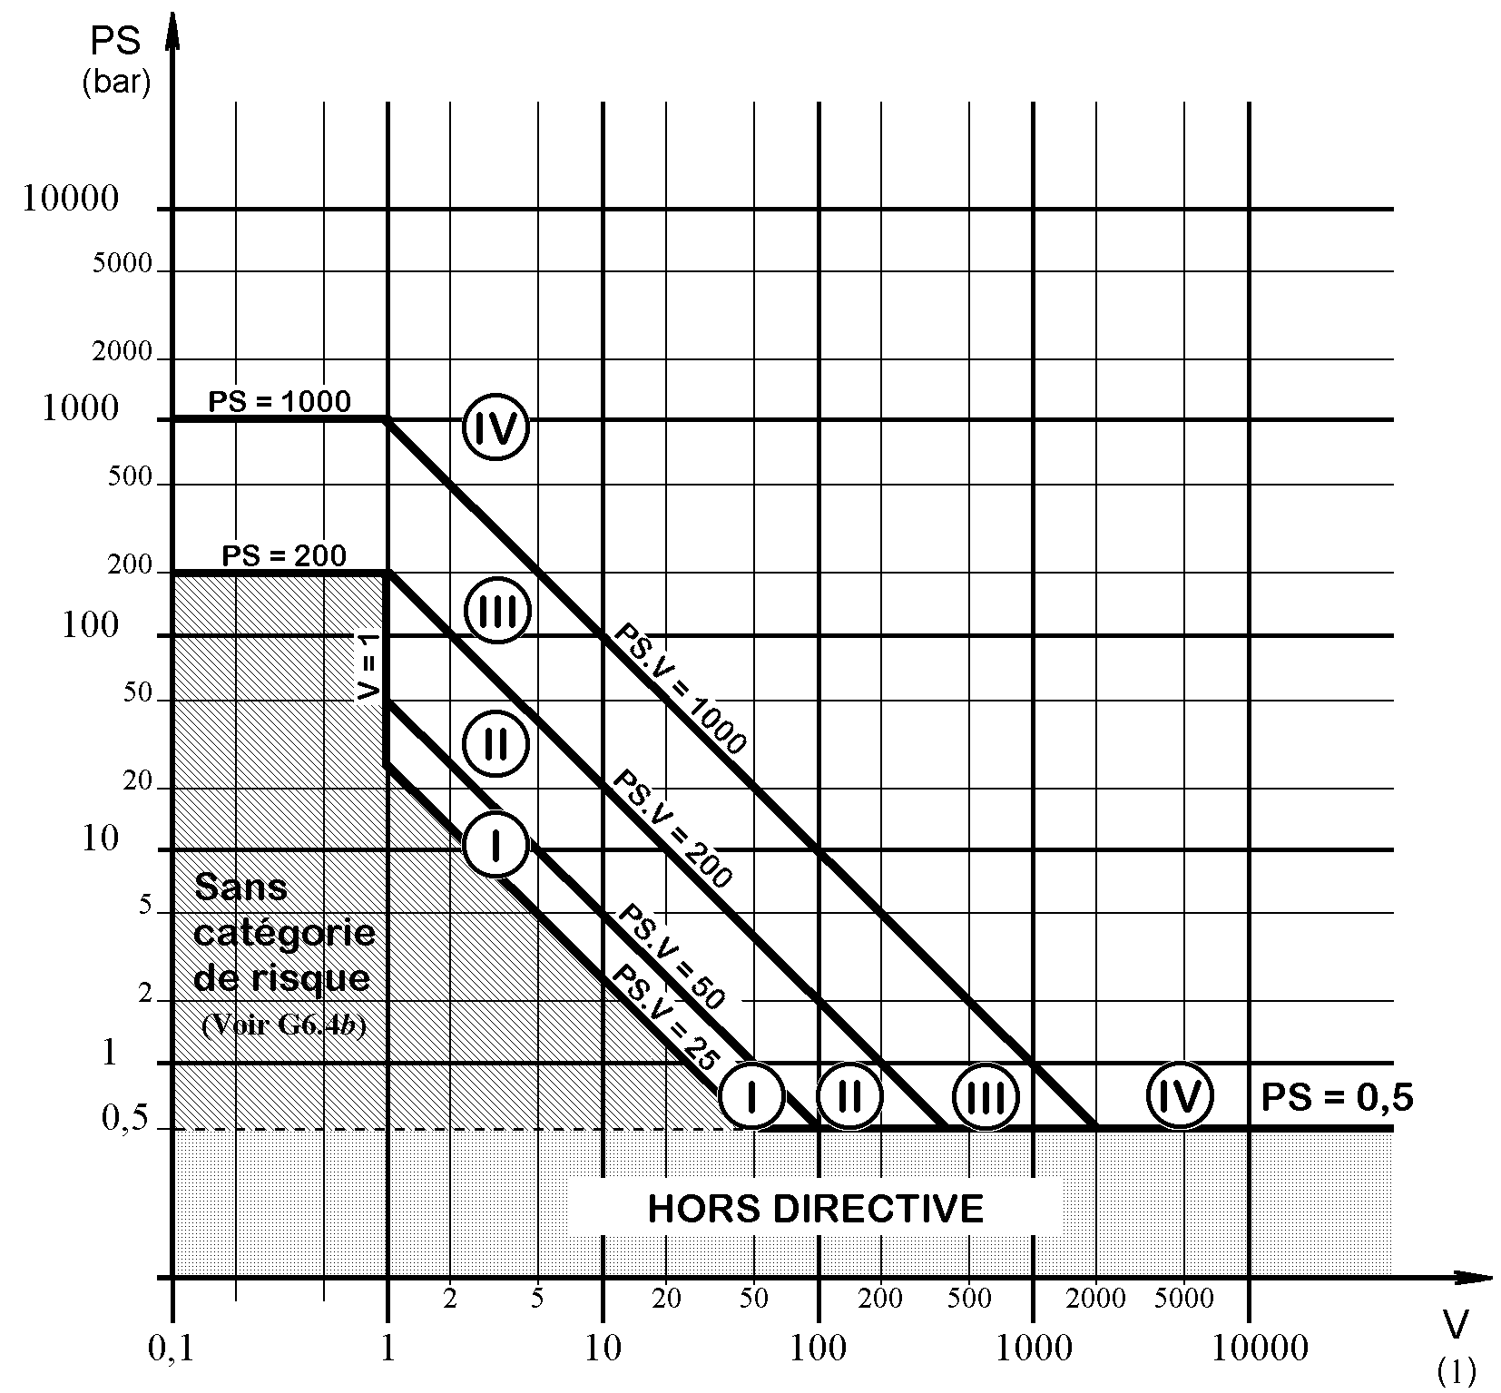

**Category 0**

**OUTSIDE ORDER**

**Figure 1 – Containers containing Group 1 “gases”:**

The term “gas” refers to:

- Gases;

- Liquefied gases;

- Gases dissolved under pressure;

- Vapours;

- Liquids whose vapour pressure at the maximum allowable temperature is higher than 0.05 MPa (0.5 bar) at normal atmospheric pressure (1,013 mbar).

Note: Exceptionally, containers designed to contain unstable gases and classified under Category I or II must be classified in Category III.

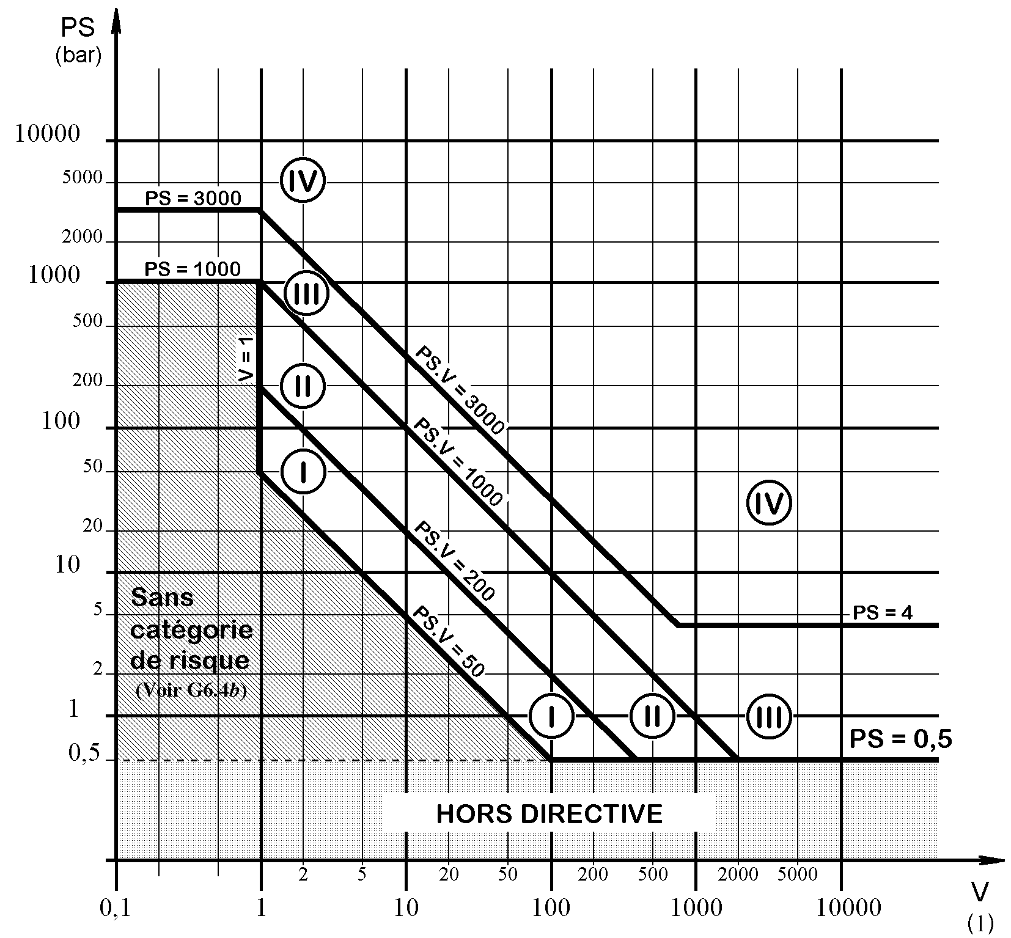

**Category 0**

**OUTSIDE ORDER**

**Figure 2 - Containers containing Group 2 “gases”:**

The term “gas” refers to:

- Gases,

- Liquefied gases,

- Gases dissolved under pressure,

- Vapours,

- Liquids whose vapour pressure at the maximum allowable temperature is higher than 0.05 MPa (0.5 bar) at normal atmospheric pressure (1013 mbar).

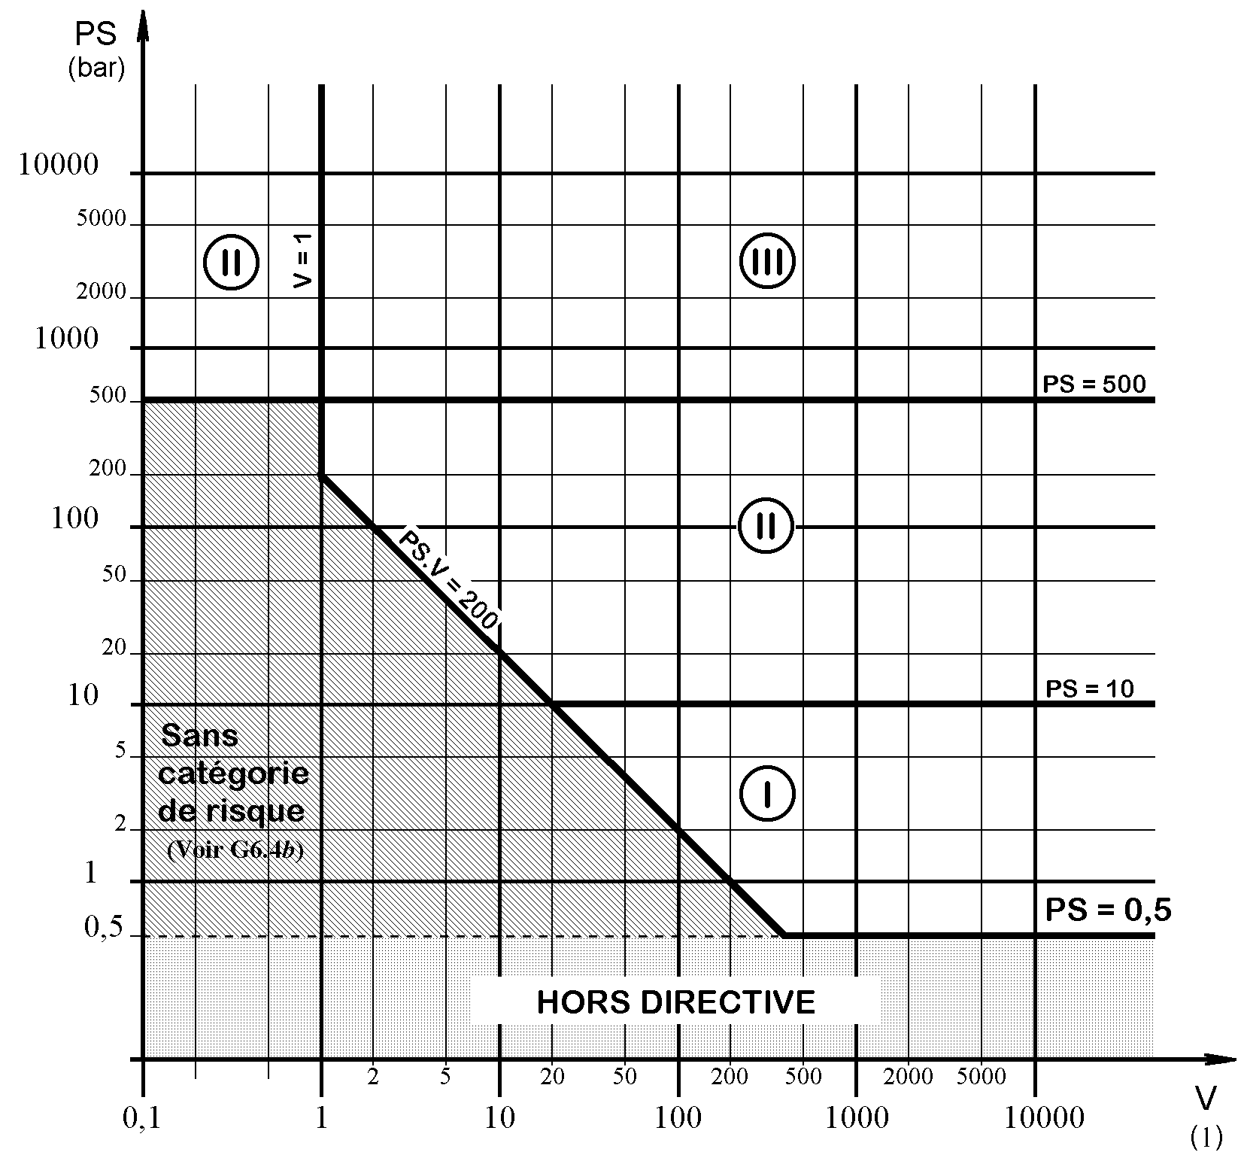

**Category 0**

**OUTSIDE ORDER**

**Figure 3 – Containers containing Group 1 “liquids”:**

The term “liquid” refers to: liquids whose vapour pressure at the maximum allowable temperature is less than or equal to 0.05 MPa (0.5 bar) above the normal atmospheric pressure (1,013 mbar).

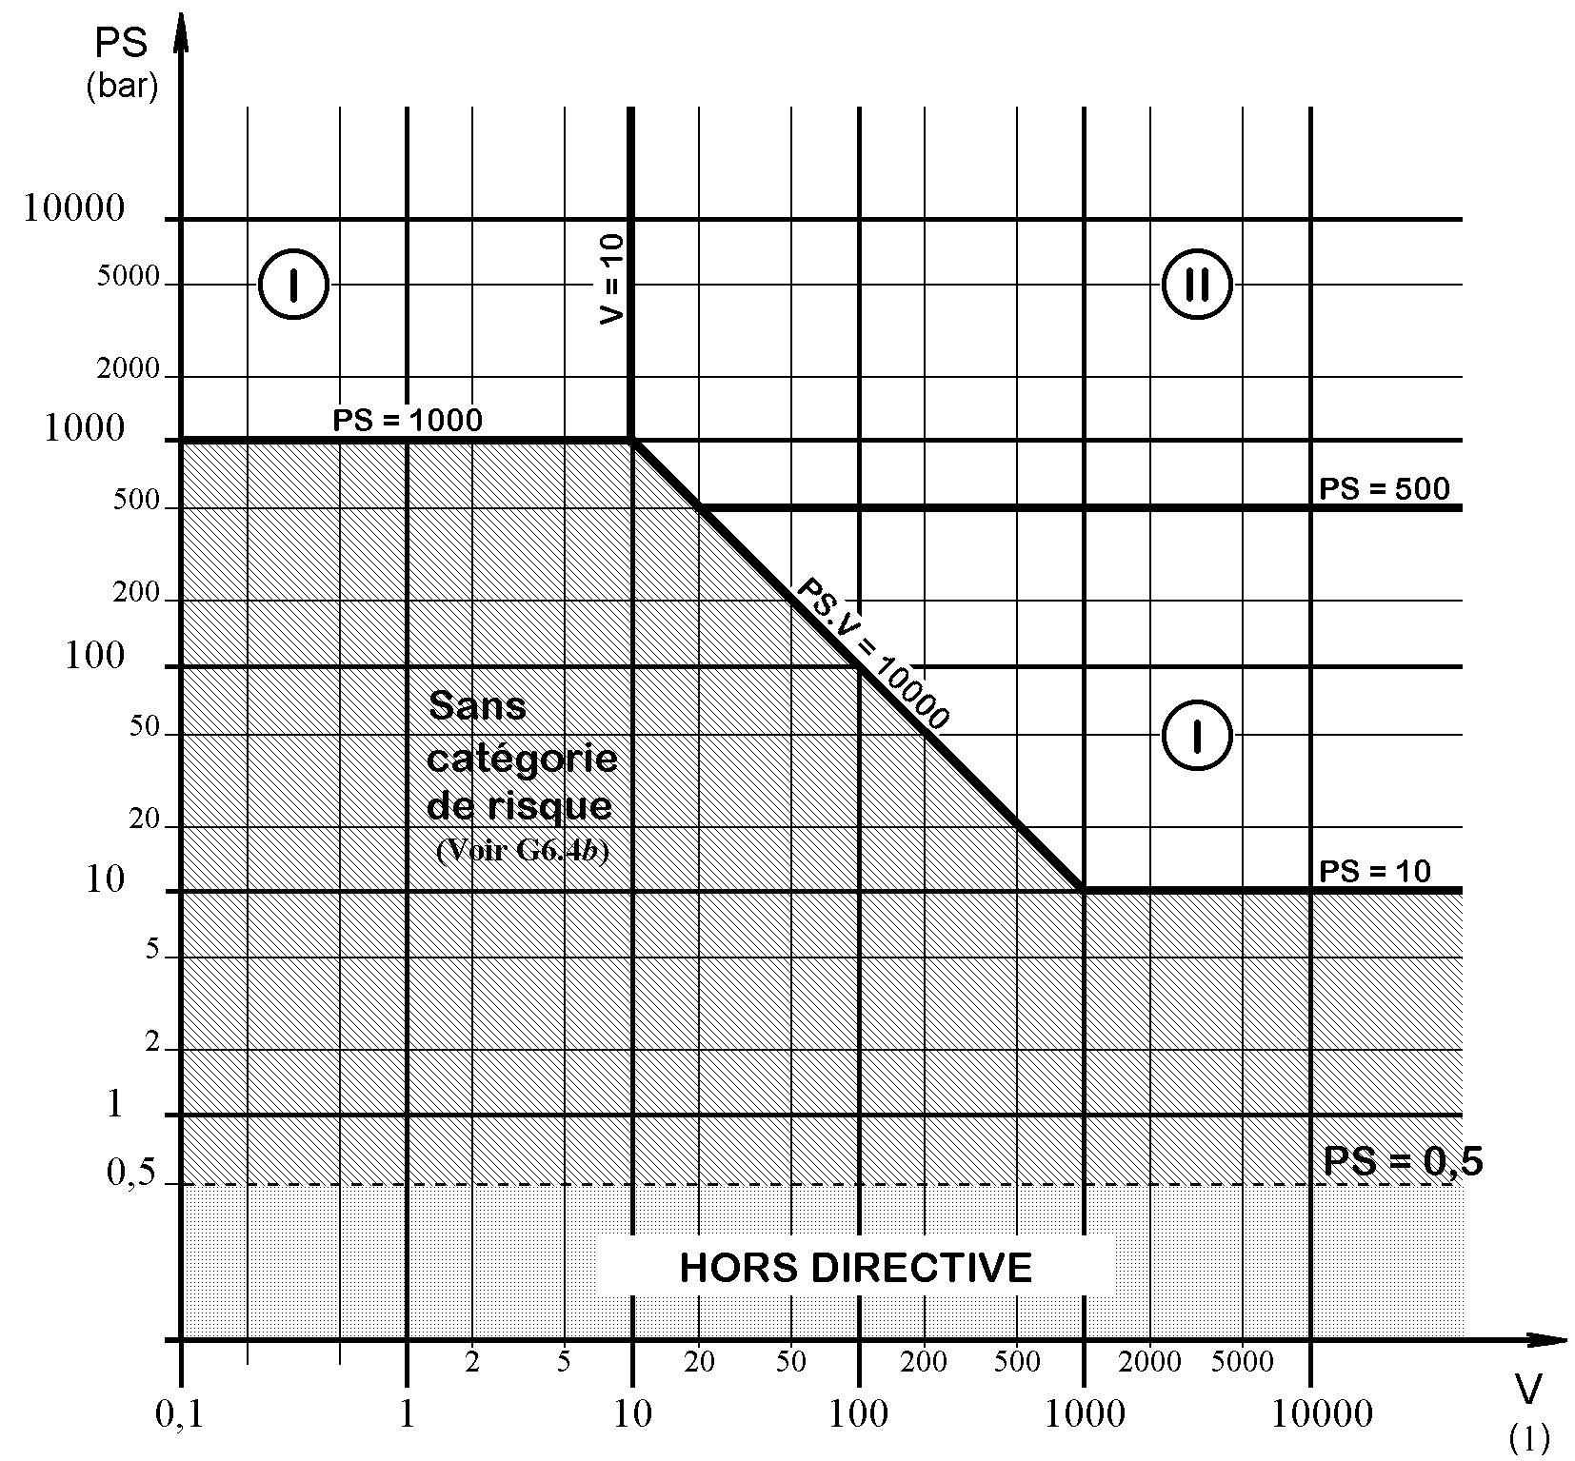

**Category**

**OUTSIDE ORDER**

**Figure 4 - Containers containing Group 2 “liquids”:**

The term “liquid” refers to: liquids whose vapour pressure at the maximum allowable temperature is less than or equal to 0.05 MPa (0.5 bar) above the normal atmospheric pressure (1,013 mbar).

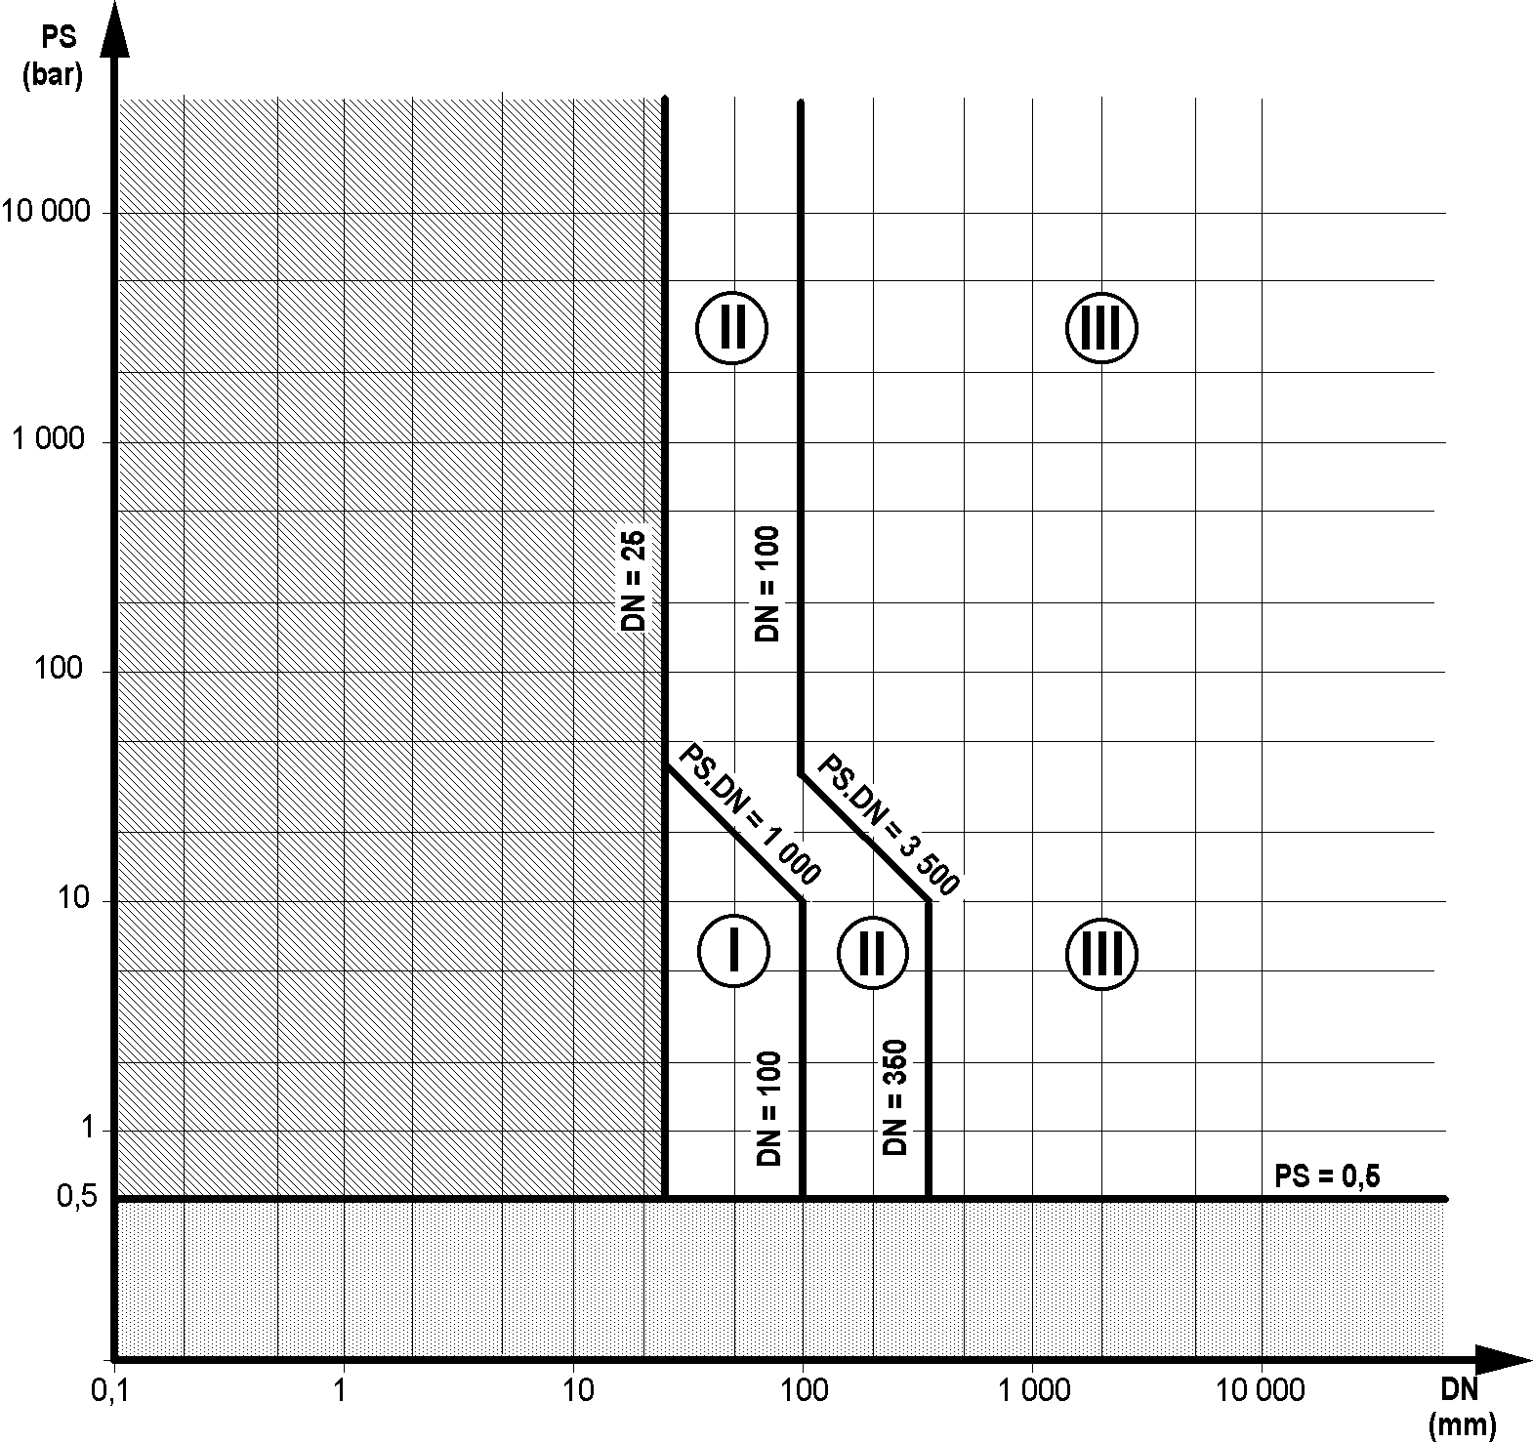

**OUTSIDE ORDER**

**Category 0**

**Figure 5:** Pipes designed for gases, liquefied gases, gases dissolved under pressure, vapours and liquids whose vapour pressure at the maximum allowable temperature is greater than 0.5 bar at the normal atmospheric pressure (1,013 mbar), **for Group 1 fluids when the nominal diameter DN is greater than 25**.

Exceptionally, pipes designed to contain unstable gases that would normally be in categories I or II, on the basis of table 1 must be classified in category III.

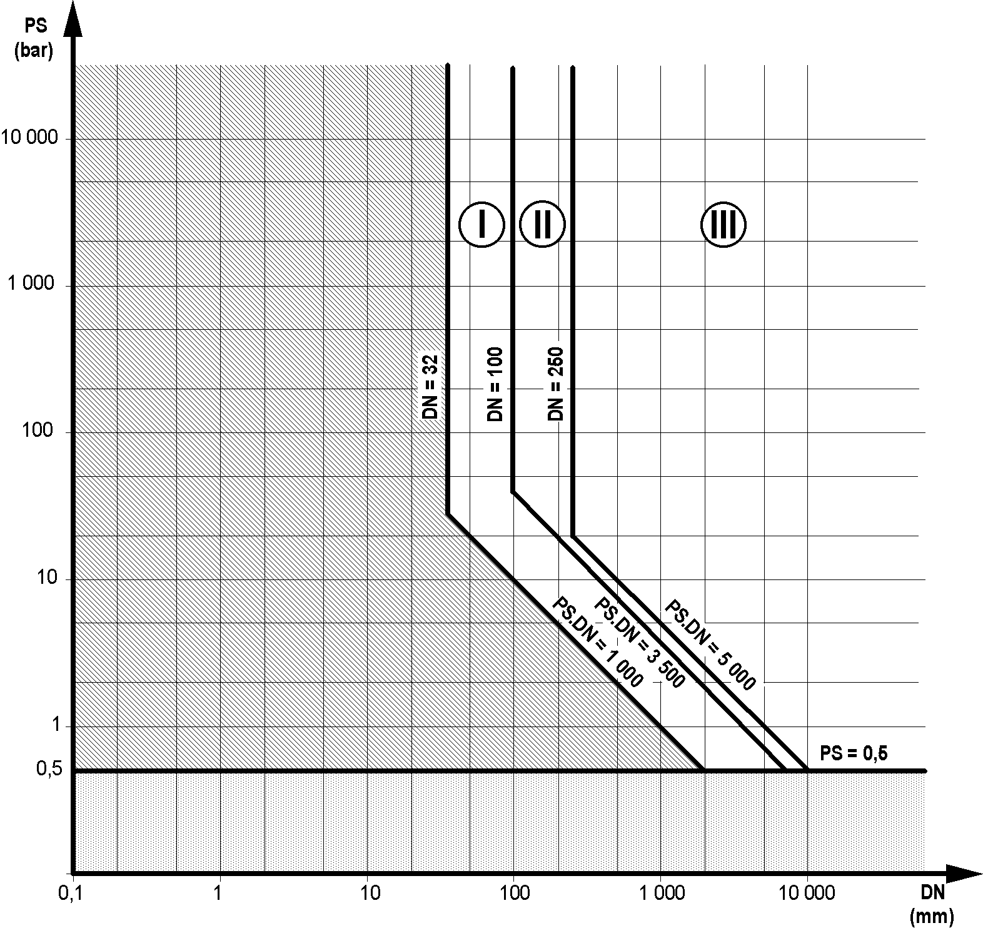

**OUTSIDE ORDER**

**Category 0**

**Figure 6:** Pipes designed for gases, liquefied gases, gases dissolved under pressure, vapours and liquids whose vapour pressure at the maximum allowable temperature is greater than 0.5 bar at the normal atmospheric pressure (1,013 mbar), **for Group 2 fluids when the nominal diameter DN is greater than 32 and the operating pressure PS multiplied by DN is greater than 1,000 bar**.

Exceptionally, pipes designed to contain fluids at temperatures above 350°C that would normally be in category II, on the basis of table 2 must be classified in category III.

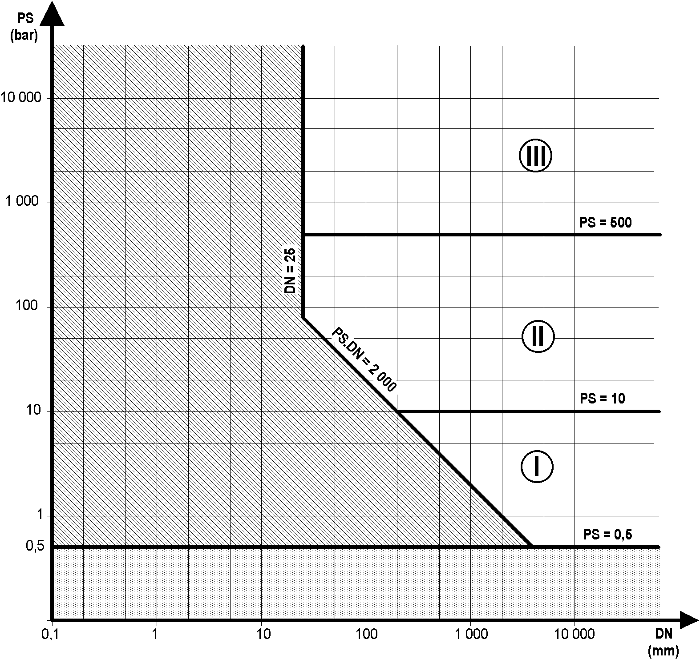

**OUTSIDE ORDER**

**Category 0**

**Figure 7:** Pipes designed for liquids whose vapour pressure at the maximum allowable temperature is less than or equal to 0.5 bar above the normal atmospheric pressure (1,013 mbar), **for Group 1 fluids when the nominal diameter DN is greater than 25 and the operating pressure PS multiplied by DN is greater than 2,000 bar.**

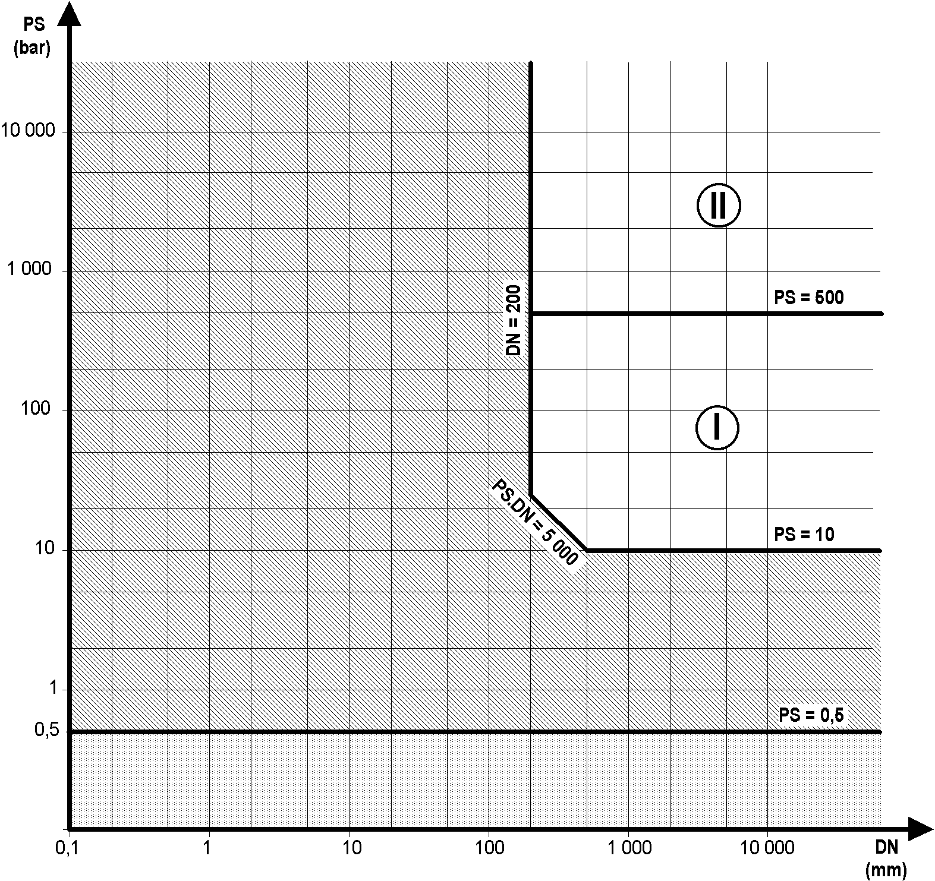

**OUTSIDE ORDER**

**Category 0**

**Figure 8:** Pipes designed for liquids whose vapour pressure at the maximum allowable temperature is less than or equal to 0.5 bar above the normal atmospheric pressure (1,013 mbar), **for Group 2 fluids when the operating pressure PS is greater than 10 bar and the nominal diameter DN is greater than 200, and PS multiplied by DN is greater than 5,000 bar.**

**APPENDIX 2: Summary of actions performed by the notified bodies or operator-specific organisations**

|  |  |  |  |  |  |  |  |  |  |  |  |  |  |
| --- | --- | --- | --- | --- | --- | --- | --- | --- | --- | --- | --- | --- | --- |
| *Conformity assessment procedures* | | **A1** | **B** | **B1** | **C1** | **D** | **D1** | **E** | **E1** | **F** | **G** | **H** | **H1** |
| **DESIGN AND MANUFACTURING** | **To be performed according to:** |  | | | | | | | | | | | |
| Risk analysis | § 3.1 |  | X | X |  |  |  |  |  |  | X | X(2) | X |
| Equipment design | § 3.2 |  | X | X |  |  |  |  |  |  | X | X(2) | X |
| Material assessment | § 3.3 | X(1) | X | X(3) | X(1) | X(2) | X(2) | X(2) | X(2) | X | X | X(2) | X(1+2) |
| QMOAP | § 3.4 | X(1) | X |  | X(1) | X(2) | X(2) | X(2) | X(2) | X | X | X(2) | X(1+2) |
| QPAP | § 3.5 | X(1) | X |  | X(1) | X(2) | X(2) | X(2) | X(2) | X | X | X(2) | X(1+2) |
| Qualification of NDT personnel | § 3.6 | X(1) | X |  | X(1) | X(2) | X(2) | X(2) | X(2) | X | X | X(2) | X(1+2) |
| Involvement during manufacturing | § 3.7 | X(1) | X |  | X(1) |  |  |  |  | X | X |  | X(1+2) |
| Instruction manuals | § 3.8 | X(1) | X | X | X(1) | X(2) | X(2) | X(2) | X(2) | X | X | X(2) | X |
| Perform or have performed the final check | § 3.9  § 3.11  § 3.10  § 5.7 | X(1) | X |  | X(1) | X(2) | X(2) | X(2) | X(2) | X | X | X(2) | X(1+2) |
| Type examination | § 3.11 |  | X |  |  |  |  |  |  |  |  |  |  |
| Identification of the notified body | § 3.13 | X |  |  | X | X | X | X | X | X | X | X | X |
| Identification of the operator-specific organisation | § 3.13 | X |  | X |  |  |  |  |  | X | X |  |  |

**Summary of actions performed by the notified bodies or operator-specific organisations**

**(cont’d)**

|  |  |  |  |  |  |  |  |  |  |  |  |  |  |
| --- | --- | --- | --- | --- | --- | --- | --- | --- | --- | --- | --- | --- | --- |
| *Conformity assessment procedures* | | **A1** | **B** | **B1** | **C1** | **D** | **D1** | **E** | **E1** | **F** | **G** | **H** | **H1** |
| **CERTIFICATES** |  |  | | | | | | | | | | | |
| Certificate of conformity | § 2.7 |  |  |  |  |  |  |  |  | X | X |  |  |
| Certificate of type or design examination | § 3.12 |  | X | X |  |  |  |  |  |  |  |  | X |
| **QUALITY SYSTEM** |  |  | | | | | | | | | | | |
| Initial assessment of the quality system | § 5.1 |  |  |  |  | X | X |  |  |  |  |  |  |
| § 5.2 |  |  |  |  |  |  | X | X |  |  |  |  |
| § 5.3 |  |  |  |  |  |  |  |  |  |  | X | X |
| Monitoring of the quality system (periodic audits and unannounced inspections) | § 5.4 |  |  |  |  | X | X | X | X |  |  | X | X |
| Specific assessment of the quality system | § 5.5 |  |  |  |  | X | X | X | X |  |  | X | X |
| Notification of decisions | § 5.6 |  |  |  |  | X | X | X | X |  |  | X | X |
| *X : Actions carried out by the notified body.*  *(1): within the context of the actions performed by the notified body or operator-specific organisation during monitoring of the manufacturer’s final check (unannounced inspections).*  *(2): notified body’s actions used as support for assessment of the manufacturer’s quality system assessment performed during monitoring of the quality system.*  *(3): according to § 3.3.2 only. Assessment of the nuclear pressure equipment with regard to the design data* | | | | | | | | | | | | | |

**Summary of actions performed by the notified bodies or operator-specific organisations**

**(cont’d)**

|  |  |  |
| --- | --- | --- |
| **ASSEMBLIES** |  |  |
| Data supplied by the operator or the assembly manufacturer | § 4.1 | X |
| Risk analysis | § 4.2 | X |
| Assembly design | § 4.3 | X |
| Equipment or intermediate assemblies assessed within the context of the assembly | § 4.4 | X |
| Changes to equipment or intermediate assemblies | § 4.5 | X |
| Actions during installation activities | § 4.6 | X |
| Protection against exceeding the allowable limits | § 4.7 | X |
| Final check | § 4.8 | X |
| Marking of the assembly | § 4.9 | X |

**APPENDIX 3: Standard content of an instruction manual**

**GENERAL**

* Description of the equipment/assembly and nuclear pressure equipment composing the assembly
* Operation of the equipment/assembly
* Fluids including for maintenance and cleaning

**INSTALLATION OF THE EQUIPMENT/ASSEMBLY**

* Storage and preservation (humidity, protection, etc.), before commissioning or during downtime
* Transport and handling (packaging, protection, anchoring points, sensitive areas, cleanliness, removal of protection)
* Space required for the installation, handling requirements and adapted machinery
* Location (distance with respect to other objects, access, inspection feasibility, etc.)
* Foundations, constraints and positioning of the supports
* Assembly conditions between equipment items (welding, bolting) and information regarding integration (geometric compatibility, weldability, tightening torques and instruction, disconnecting load sets)
* Condition of the installation on which the equipment must be installed (drained systems, dry system, cleanliness, etc.)
* Actions that can be carried out as part of installation which do not threaten conformity
* Protection against external aggressions on site
* Risks which may result in foreseeable improper use
* Other residual risks to be taken into account

**COMMISSIONING**

* Checks before commissioning
* Commissioning procedure (filling and draining points, appropriate quantity of fluid, pressurisation and heating operations, points to be monitored, etc.)
* Risks which may result in foreseeable improper use,
* Radiation protection system
* Other residual risks to be taken into account

**USE**

Design bases and safe service limit:

* Situations taken into account upon design
* Code, design conditions, welding joint coefficient, corrosion overthickness,
* Allowable minimum/maximum limits (pressure, temperature, etc.)
* Level monitoring
* Maximum fluid mass
* Insulating casing, vitrified linings
* Specific operating and restarting procedures depending on the various causes of interruption
* Filling (starting, make-up) and draining
* Control and safety devices
* Nature of hazardous products for the equipment
* Risks which may result in foreseeable improper use,
* Radiation protection system
* Other instructions relating to safe service limits

Important design characteristics for service life

* Creep resistance: forecast service life
* Fatigue resistance: number of cycles taken into account upon design
* Corrosion resistance: corrosion overthickness planned upon design,
* Abrasion resistance: precautions of use and limit thicknesses, etching of the linings,
* Erosion resistance: precautions of use and limit thicknesses, etching of the linings,
* Irradiation resistance (case of reactor pressure vessels): creep or forecast service life, monitoring
* Record of operating parameters
* Other instructions relating to important design characteristics for the service life

**MAINTENANCE – IN-SERVICE INSPECTION**

* Maintenance and cleaning precautions in light of knowledge available during drafting of the manual
* Check and calibration of inspection and control devices and safety accessories (nature, frequency)
* Check of linings
* Other points subject to monitoring (leakage, etc.)
* Elements to be taken into account for the inspections to be performed on the equipment (areas, number of welds to be inspected, any recommendations for the inspection instruments and equipment and the implementation frequency, etc.)
* Risks which may result in foreseeable improper use
* Radiation protection system
* Removable parts, disassembly, possible access to perform inspections,
* Lists, references, characteristics of the replaceable components likely to suffer foreseeable wear (connections, joints, etc.) or used components (oil, grease, etc.) and the procedures to be implemented for replacing these parts
* References, characteristics of protections and linings likely to be replaced (insulator, etc.)
* Other residual risks to be taken into account

**DOCUMENTATION, DRAWINGS AND DIAGRAMS**

**EXPLAINING THESE INSTRUCTIONS**

* Documentation, drawings and diagrams appended to this manual

**MARKING – IDENTIFICATION**

* Content and meaning of the marking elements:
* Warning to be affixed
* Preservation of the marking

|  |
| --- |
| **COMPENDIUM OF ASN GUIDELINES** |
| No.1 Permanent storage of radioactive waste in deep geological formation  No.2 Transport of radioactive material in airport zone  No.3 Recommendations for drawing up the annual reports for public information regarding licensed nuclear facilities  No.4 Self-assessment of the risks incurred by patients in external radiotherapy  No.5 Management of the safety and quality of radiotherapy care  No.6 Decommissioning, dismantling and declassification of licensed nuclear facilities in France  No.7 Approval request for shipment and approval of the packaging models or radioactive materials for civil use transported on the public thoroughfare  No.8 Conformity assessment of nuclear pressure equipment  No.10 Local involvement of CLIs in the 3rd ten-year visit of 900 MWe reactors  No.11 Declaration and coding of criteria relating to significant events in the field of radiation protection (excluding INB and transport of radioactive materials)  No.12 Declaration and coding of criteria relating to significant events involving safety, radiation protection or the environment applicable to INB and to transport of radioactive materials  No.13 Protection of licensed nuclear facilities against external flooding  No.14 Full sanitation methodologies acceptable in the licensed nuclear facilities in France  No.15 Safety management policy in the INBs  No.16 Significant radiation protection event for patients in radiation therapy: declaration and classification on the ASN-SFRO scale  No.18 Disposal of effluents and waste contaminated by radionuclides produced in the facilities authorised under the French Public Health Code |



**FRENCH NUCLEAR SAFETY AUTHORITY**

6, place du Colonel Bourgoin

75012 Paris, France

Telephone + 33 (0)1 40 19 86 00

Fax + 33 (0)1 40 19 86 69



1. Nuclear pressure equipment liaison committee
2. This terminology will be included in a later revision of the order [5]
3. This provision will be included in a later revision of the order [5]
4. This provision will be included in a later revision of the order [5]
5. Intermediate according to § 6 of standard NF EN 10204 version 2005
6. Refer to COLEN 7A and 3A sheets
7. The difficulty in performing the visual inspection is to be assessed based on the technical and practical progress at the time of manufacture.