PERSONAL INFORMATION | Yannick PARIS
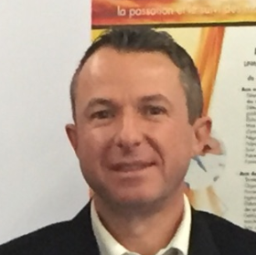 | 3, Chemin du Quartier 21310 JANCIGNY - FRANCE
 | +33(0)673371845
 | yannick.paris@lpme.fr
 | Sex Male Date of birth 15/06/1973 Nationality French

Member of the Fusion for Energy Procurement and Contracts Committee

WORK EXPERIENCE

From 2009  From 2003 to 2009  From 1998 to 2003 | CEO – LPME (Dijon - France) spin-off from the CEA
From 2009  From 2003 to 2009  From 1998 to 2003 | Head of the Procurement Département – Commissariat à l’Energie Atomique et aux énergies alternatives (CEA) – Valduc (21 - France)  Deputy Head of the Procurement Departement – Commissariat à l’Energie Atomique et aux énergies alternatives (CEA) – Cadarache (13 - France)

EDUCATION AND TRAINING

1998  2018 | Graduated from Burgundy School of Business  (High Business School BSB- France)
1998  2018 | Graduated from PARIS 1 SORBONNE UNIVERSITY (Paris – France) Droit des entreprises en difficulté

PERSONAL SKILLS

Mother tongue(s) | FRENCH
Other language(s) | UNDERSTANDING |  | SPEAKING |  | WRITING
Other language(s) | Listening | Reading | Spoken interaction | Spoken production
ENGLISH | Independent user
GERMAN | Basic user

Communication skills | - good communication skills gained through my experience as CEO

Organisational / managerial skills | - leadership (currently responsible for a team of 14 people)

Job-related skills | - Procurement strategy, contract management

Digital competence | SELF-ASSESSMENT
Digital competence | Information processing | Communication | Content creation | Safety | Problem solving
 | Independent user | Independent user | Independent user | Independent user | Basic user

Other skills | Judge at commercial court

Driving licence | B, A.

